Samuel I. Templeton
1898 – August 17, 1970
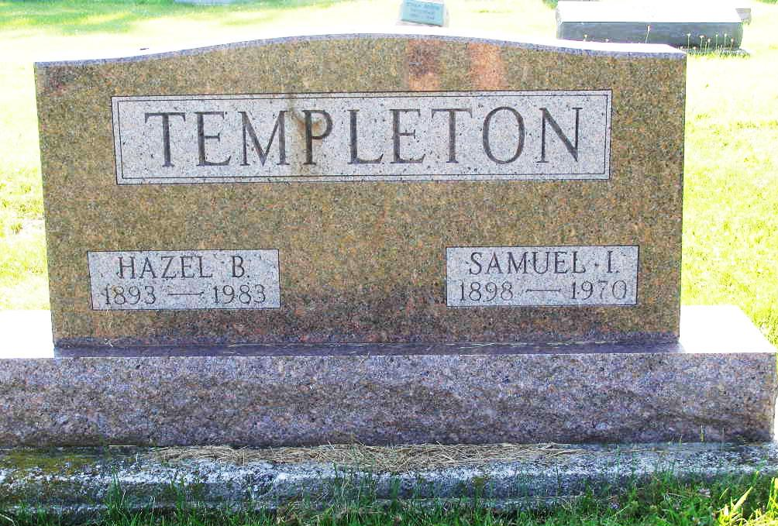
Photo by Shaunda Bedwell

Samuel I. Templeton
Death: August 17, 1970
Burial: August 20, 1970
Buried: Lot 197, Original Platt

Huntington –

Admitted August 3, Samuel I. Templeton, 71, died at 10:40 am Monday in the Huntington County Hospital. The wife, formerly Hazel Shaefer; two sons, one stepson, eight grandchildren, two sisters survive.
Calling after 7 pm Tuesday at the Bailey Mortuary. Services there at 2 pm Thursday.

Berne (IN) Library Heritage Room
MRE Obits 1969 - 1972
Transcribed by Jim Cox

