Martha Anna (Neuenschwander) Welty
May 12, 1904 – November 27, 1971
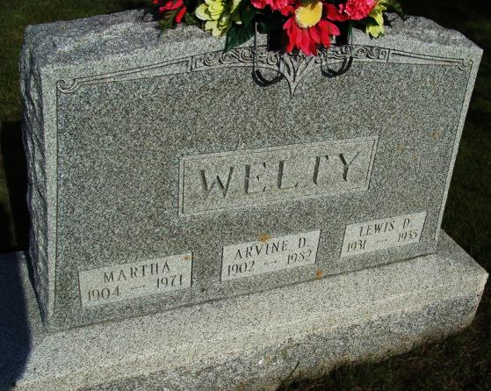
Photo by Alicia Kneuss

Date of Death: November 27, 1971; Date of Burial: November 29, 1971; Burial: MRE

Funeral Today for Wife of Arvine Welty
Local Woman, 67, Dies Saturday in County Hospital

Services were held in the chapel of the First Mennonite Church this afternoon for Mrs. Martha Welty, 67, wife of Arvine Welty of 706 South Harrison Street, this city, who died at 4 pm Saturday. Rev. Gordon Neuenschwander and Rev. Gerald Stucky officiated and burial was in the MRE Cemetery.
Mrs. Welty died at the Adams County Memorial Hospital from heart failure. She was admitted to the hospital on Friday, a day before her death. She had ailed for a number of years, becoming seriously ill September 12, spent three weeks in the hospital, then returned to her home.
Mrs. Welty was a member of the First Mennonite Church and the WMS of the church in which she was active for many years.
She was born in the community May 12, 1904, a daughter of Chris and Anna Amstutz Neuenschwander. She was married in Berne September 2, 1928 to Arvine Welty. Mr. Welty was manager of the Berne-Geneva Livestock Sales for many years.
Surviving are the husband; a daughter, Mrs. Arthur (Ruth Ann) Hunsberger, Findlay, Ohio; two grandchildren; four brothers, Noel, Joel and Amos Neuenschwander, all of Berne and Enos of R. R. 1, Monroe and a sister, Mrs. John (Diane) Wornick, Burbank, California. A son, Lewis D., died in infancy and three sisters, Sarah, Bertha and Lydia preceded in death.

Berne (IN) Library Heritage Room MRE Obit Book 1966-1972 Transcribed by Jim Cox

