Rev. Rollo O. Wine
December 13, 1890 – February 23, 1950
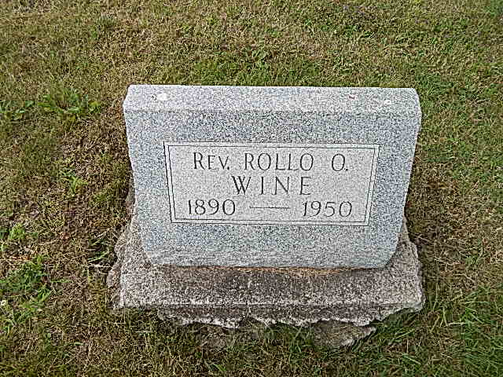
Photo by Alicia Kneuss

Rev. Mr. Wine’s Funeral Slated In Berne Sunday

The Rev. Rollo O. Wine, 59, of Ft. Wayne, a former evangelist and son-in-law of Mr. and Mrs. Emil Liechty of Linn Grove, died suddenly of a heart attack Thursday evening at his home in Trailer Haven near Ft. Wayne. He had not been ill.
Mr. Wine was the husband of the former Coyla Liechty, a sister of Mrs. Jesse Stookey of Portland and Mrs. Tilman Kirchhifer of Berne.
Mr. Wine was born in South English, Ia., on Dec. 13, 1890, the son of William and Barbara Flory Wine. He was married to Coyla Liechty. He was pastor of a Baptist church in Toledo, O., for a number of years and then entered evangelistic work.
Surviving besides the widow are the following sisters and brothers: Mrs. John Hull, Fort Collins, Col., Mrs Carl White, Des Moines, Ia., Mrs. Vern Marr, Loveland, Col., and George J. Wine, North English, Ia. A brother and sister are deceased.
Funeral services will be held Sunday afternoon at 2 o’clock at the Yager Funeral Home in Berne with the Rev. Earl Tauber officiating. Burial will follow in the M.R.E. Cemetery.
Friends may call at the funeral home after 6:30 Saturday evening.

Portland Commercial Review, Jay County, IN; February 25, 1950

