Homer Winteregg
October 2, 1894 – December 20, 1977

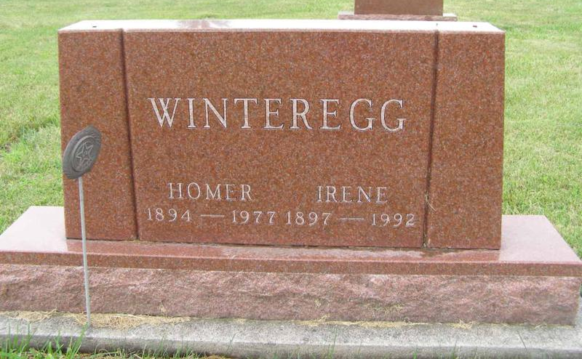
Photo by Shaunda Bedwell

Homer Winteregg, 83, 118 East Walnut Street, Monroe, one of the county’s most prominent citizens, was dead on arrival at 6:50 am Tuesday at the Adams County Memorial Hospital. Mr. Winteregg was stricken in the bathroom of his home and death is attributed to a heart attack.
Mr. Winteregg was active in church, community and business circles and was greatly interested in extension and 4-H activities and the welfare of young people. He was a member of the Monroe United Methodist Church and taught a Sunday School class for 50 years. He was president of the Monroe Town Board for 25 years, employed by the Indiana State Highway Dept. 12 years and a dealer in Moorman’s Feeds for 16 years before his retirement in 1960. Mr. Winteregg was a veteran of World War One and a member of American Legion Post 43 in Decatur.
Though in failing health for some time, Mr. Winteregg was up and around and able to attend church regularly.
A native of Berne, he was born October 2, 1894, a son of David and Louise Baumgartner Winteregg. He married Irene Stuckey on October 9, 1921.
Surviving is the wife; a son, Max E. Winteregg, Fort Wayne; three grandchildren and two sisters, Mrs. Noah (Elda) Graber and Mrs. Eli (Leona) Graber, both of Berne. A brother and two sisters preceded in death.
The body is at the Winteregg-Linn & Haggard Funeral Home in Decatur where friends may call after 7 pm today. Services will be held at 11 am Friday at the Monroe United Methodist Church, Rev. Donald Wilks officiating. The body will lie in state at the church from 9:30 am Friday until the time of the services. Burial will be in the M.R.E. Cemetery, west of Berne.
Preferred memorials are to the memorial fund of the Monroe United Methodist Church.

Newspaper clipping from the Florence Gause Collection dated December 21, 1977

