Arthur Conrad Wittwer
September 28, 1892 – March 21, 1971

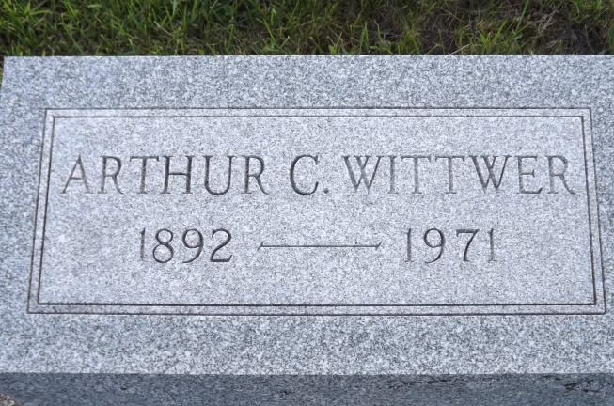
Photo by Jim Allen

BERNE - Word has been received of the death of Arthur Conrad Wittwer, Berne native, at North Largo, Fla. He was a retired salesman and formerly resided in Fort Wayne. One nephew, John C. Wittwer, Mt. Kisco, NY survives
Journal-Gazette, Fort Wayne, IN; March 26, 1971
*****

Date of Death: 1971
Date of Burial: Cremation Service
Burial: MRE

Memorial Service Here Saturday for Arthur C. Wittwer

A memorial service for the late Arthur Conrad Wittwer, 75, who died recently at Largo, Florida where he resided the last ten years of his life, will be held at 1:30 pm next Saturday at the MRE Cemetery west of Berne. Rev. LaVerne Howard, pastor of the Trinity Methodist Church of this city will officiate at the service. The remains of Mr. Wittwer have been at the Yager Funeral Home the past week.
A native of Berne, Mr. Wittwer was a retired salesman, school teacher and musician. He is survived by a nephew, John C. Wittwer, Mt. Kisco, New York.

Berne (IN) Library Heritage Room
MRE Obit Book 1966-1972
Transcribed by Jim Cox

FL Death Index: Arthur Conrad Wittwer 9/28/1892 – 3/21/1971, Pinellas, FL

