Samuel Wittwer
February 1, 1877 – June 16, 1962

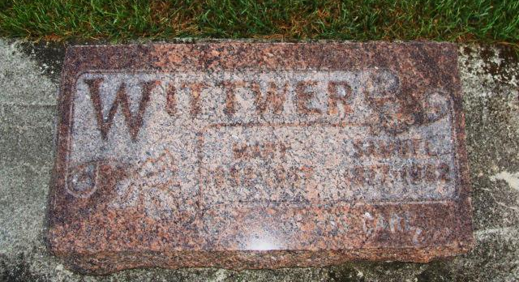
Photo by Alica Kneuss

Samuel Wittwer Service Held This Afternoon
Local Man, 85, Dies early Saturday At Nursing Home

Samuel Wittwer, 85, widely known local man and a retired plasterer, died at 4:45 a.m. Saturday at the Berne Nursing home, following an extended illness. He had been in the nursing home the last few weeks after being in the Adams County Memorial hospital for a few weeks. His condition has been very poorly for some time.
A lifelong resident of this community, Wittwer was employed as an upholsterer in addition to being a plasterer for many years.
Mr. Wittwer was married to Mary Zimmerman, who preceded in death five years ago. He lived in Portland for one year but the rest of his life was spent in this community
Surviving are six daughters; Mrs. Felix Yost of Fort Wayne, Mrs. Lester Reynolds of Linn Grove, Mrs. Frank Liechty of near Berne, Mrs. Elvet Dawe of North Ridge, Calif., Mrs. Robert Welch of Monroe, and Miss Phyllis Wittwer of Bern; five sons, Vilas Wittwer of Richmond, John Wittwer of North Manchester, Jesse Wittwer of Fort Wayne Weldon Wittwer of Berne, and Kenneth Wittwer of Sebring, Fla.; 31 grandchildren; 31 great-grandchildren; one brother, Hiram Wittwer of Monroe, and one sister, Mrs. Rosina Neukom of Decatur. Two sons are deceased. One of the sons, Laverne, died recently in Florida, the other died in infancy.
Services were held at 2 p.m. today, at the First missionary church, of which he was a member. Rev. c. H. Wiederkehr, pastor of the church, officiated and burial was in the M.R.E. cemetery. (Monday, June 18, 1962)

Berne Library Heritage Room
Adams County Obits 1962-1964
Transcribed by Janice Vasilovski

