Lawrence L. Yager
March 5, 1883 – July 4, 1950
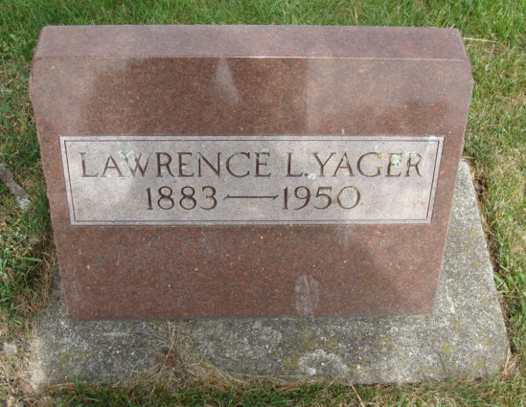
Photo by Alicia Kneuss

Lawrence Yager Dies Suddenly At Pine Lake

Lawrence L. Yager, 67, funeral director and furniture dealer at Berne, died suddenly Tuesday afternoon at 4:15 o’clock at his son Jerome’s lake home at Pine Lake, following an illness of one day from coronary occlusion. Mr. Yager did not rest well Monday evening and did not feel like eating at a forty-year wedding anniversary dinner in his honor Tuesday noon. In the afternoon, he reclined on the porch visiting with his brother-in-law, Dr. S. P. Hoffman of Fort Wayne and Rev. C. A. Schmid, when he suddenly passed away.
The body was returned to the Yager funeral home where friends may call. The body will lie in state at the Cross Evangelical and Reformed Church from 12 o’clock noon Friday until the hour of the funeral at 2 o’clock. Rev. C. A. Schmid will officiate and interment will be in the Berne M. R. E. cemetery.
Mr. Yager was one of Bern’s most prominent and influential citizens. He was born in Jefferson township, Adams county, March 5, 1883, son of the late Charles and Magdalene Beitler Yager. With E. C. Bierie, he founded the Bierie and Yager Furniture store in Berne, which is now the Yager Furniture Co., Inc. He was instrumental in starting both the Dunbar Furniture Manufacturing Co., and the Berne Furniture Co. and led the movements for the establishments of the Berne auditorium as well as other civic enterprises and church activities. He was a trustee of the Reformed Church and only Monday evening attended a session of the board. He had been president of the Berne Furniture Co. since its organization and had also been a former town board president and clerk-treasurer.
He was united in marriage to Nona Hoffman July 4, 1910 and she survives with two sons, L. Luther, Berne R. R. 1 and J. Jerome of Berne. Surviving also are six grandchildren, two sisters, Mrs. Rose Moran of Indianapolis (cut off)

*****
Portland Commercial Review, Jay County, IN; July 5, 1950

(Handwritten date: Wednesday, July 5, 1950)

DIES SUDDENLY LATE TUESDAY
Prominent Berne Businessman and Civic Leader Dies

Lawrence L. Yager, 67, one of Berne's business and civic leaders, died suddenly at 4:15 o'clock Tuesday afternoon of a heart attack at Pine Lake, west of Berne.
Mr. Yager was seated on the porch of a cottage owned by his son, J. Jerome Yager, when stricken. He died instantly of a coronary occlusion. Death came as a severe shock to his family and friends, as he had not been ill.
The Yager family had gathered at the lake cottage to celebrate the 40th wedding anniversary of Mr. and Mrs. Yager.
Mr. Yager was president of the Yager Furniture, Inc., furniture dealer and morticians, and president of the Berne Furniture Co. He was instrumental in founding the latter company and also the Dunbar Furniture Co. He was a charter member of the Berne Auditorium.
He first entered business in Berne in 1910 with Eli C. Bierie and was one of the ??? had served as president of the Berne town board, and as town clerk ??
Mr. Yager was a highly active (cut)
Surviving in addition to his wife are two sons, Luther and Jerome, both associated in business with their father; six grandchildren; one brother, Marcus Yager of West Unity, O., and two sisters, Mrs. Rose Moran of Indianapolis and Mrs. J. R. Zimmerman of Fort Wayne.
Funeral services will be held at 2 p.m. Friday at the Cross Evangelical and Reformed church, the Rev. C. A. Schmidt officiating. (cut off)

(Karin King note: Lawrence Yager is buried at MRE Cemetery, Berne, Adams County, Indiana)

Adams County Historical Museum
1933-1953 Scrapbook, Image 039
Transcribed by Karin King

