Jimmie E. (Clifton) Yoder
October 26, 1932 – April 20, 2015

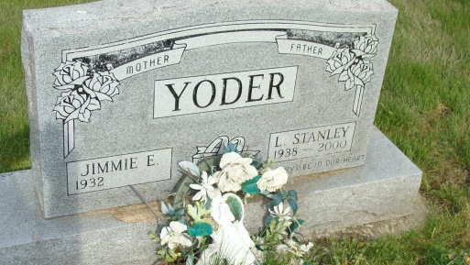
Photo by Alicia Kneuss

Jimmie E. Yoder, 82, Wolcottville, IN passed away on Monday, April 20, 2015 at her home. She was born to Eugene and Eula Nicholson Clifton on October 26, 1932. She married Stanley Yoder on April 9, 1967.
Jimmie was a member of the Waynedale Baptist Church and was a former employee of Berco Co.in Berne. She attended Fort Wayne Bible College where she attained a degree in Early Childhood Development. She and Stanley were licensed children providers for many years. Interests include: reading, gardening, raising flowers, and listening to Jim Reeves music.
Survivors include: Gene (Vicki) Yancy of Almont, MI., Theresa Liechty of Aurora, IL., Vicki (John) Worman of Wolcottville, Steve Yancy of Esmond, IL., Brenda Moore of Berne, children; Scott Yoder of Tampa, FL., Sonja McCaughey of Tampa, Fl., Wade Yoder of New Haven, half sister, Peggy Ward of GA., 17 grandchildren and 31 great-grandchildren.
Preceding in death are her husband, daughter Sherry Yancy, son Lynn Yancy, great grandchild, Christian Ruckman, sister, Juanita Lahr, brother, Joe Clifton, and Jerre (Mize) Canada.
Funeral services are Friday, April 24 at 1 PM at the Yager-Kirchhofer Funeral Home, Berne with visitation from 10 AM to time of services. Officiating is Pastor James Moser. Burial is in the MRE Cemetery, Berne.
Preferred memorials to Waynedale Baptist Church or Donor’s Choice.

Yager-Kirchhofer Funeral Home online obit (accessed April 21, 1915)

