Felix Peter Yoss
September 14, 1897 – July 19, 1971
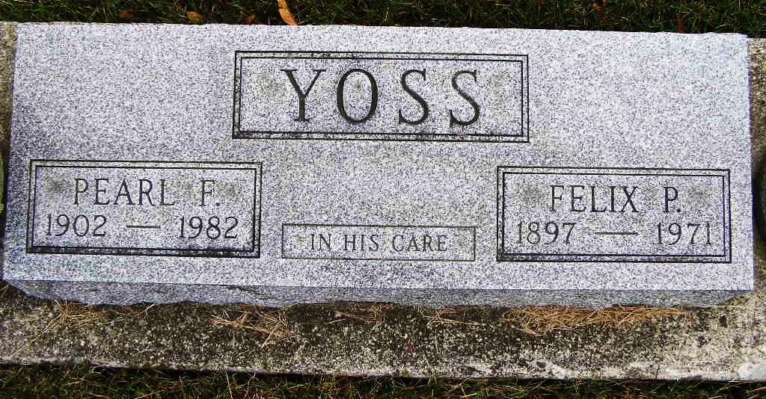
Photo by Shaunda Bedwell

Felix Yoss

Date of Death: 1971

Funeral Thursday for Felix Yoss, 73

Services will be held at 2 pm Thursday in the D.O. McComb & Sons Funeral Home, Fort Wayne for Felix Yoss, 731 Michaels Avenue, Fort Wayne, who died at 11:25 am Monday in Parkview Memorial Hospital after an extended illness.
The Rev. Rex Custer will officiate and burial will be in the MRE Cemetery west of Berne.
Friends may call at the funeral home.
Born near Berne, the son of Fred and Lena Lehman Yoss, Mr. Yoss lived in Fort Wayne 40 years. He was retired as owner and manager of the High Street Food Shop which he operated 30 years. He was a member of F.O.E.
Surviving are his wife, Pearl F.; two sons, Fred S., Fort Wayne and Max E., Warsaw; two daughters, Mrs. Gene Richards and Mrs. Marilyn Stevens, both of Fort Wayne; a brother, Paul, Geneva; five sisters, Mrs. Blondie Doty and Mrs. Irene Blake, Fort Wayne, Mrs. Irvin Sprunger, Geneva, Mrs. Cora Fennig, Berne, and Mrs. Sophie Faulkner of Kentucky; 12 grandchildren and three great grandchildren.
Berne (IN) Library Heritage Room
MRE Obits 1969 – 1972
Transcribed by Jim Cox

