Leah (Lehman) Yoss
April 7, 1862 – August 18, 1950
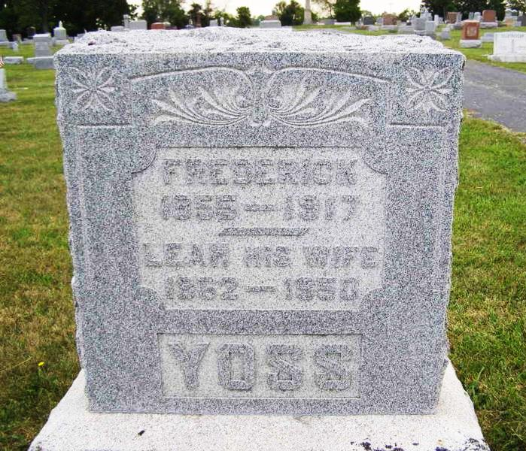
Photo by Shaunda Bedwell

MRS. LEAH YOSS DIES AT BERNE BERNE

- Mrs. Leah Yoss, 88, died at 3:20 p.m. yesterday at her home here. She had been bedfast two months. A native of Switzerland, she had resided in Adams County 65 years.
Surviving are seven daughters: Mrs. Mary Bill, Mrs. Irene Blake and Mrs. Blondie Frankart, all of Fort Wayne; Mrs. Lillian Sprunger, near Geneva; Mrs. Cora Fennig and Mrs. Lenore Schug, both of Berne; and Mrs. Sophia Faulkner, Index, Ky.; four sons, Felix, Fort Wayne; Anatole, New Castle; and Garfield and Paul, both of near Geneva; 32 grandchildren; 36 great-grandchildren; a brother, Carl Lehman, Berne and a sister, Mrs. Mathilda Nagle, also of Berne.
Mrs. Yoss was a member of the First Mennonite Church here, where services will be conducted at 2 p.m. Sunday. John F. Sprunger and the Rev. J. Pritchard Amstutz will officiate and burial will be in the MRE Cemetery. The body, taken to the Yager Mortuary, will be returned to the residence, where friends may call after 6 p.m. today.

Portland Commercial Review, Jay County, IN; August 19, 1950

Contributed by Karin King

