Dore Earl Anspaugh
November 11, 1885 – May 26, 1959

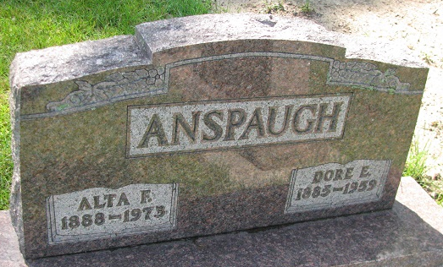
Photo by PLS

DORE ANSPAUGH OF JEFFERSON TOWNSHIP DIES
Heart Ailment Fatal To Farmer; Rites Here Thursday

Dore E. Anspaugh, 73, widely known Jefferson township farmer, died at 2:30 a.m. Tuesday in his home, 8 1/2 miles southeast of Berne. Death was attributed to a heart attack. He had been in failing health for some time but had not been ill.
A lifelong resident of this community, Anspaugh was born in Jefferson Township Nov. 11, 1885, the son of Noah W. and Emma Jane Tester Anspaugh. He was married October 11, 1905, to Atta [sic] Mann.
Surviving are the widow; two sons, Ernest C. Anspaugh, Seymour and Merrill A. Anspaugh, Fort Wayne; a daughter, Mrs. Woodrow (Vera) Kelly, Geneva R. R. 2; 10 grandchildren; eight great-grandchildren and four brothers, James L. Anspaugh, Lansing, Michigan; Edward S. Anspaugh, Mendon, Ohio; Elmer Anspaugh, Fort Wayne and George Anspaugh, Decatur.
The body is at the Yager Funeral Home where friends may call. Services will be held at 2 p.m. Thursday at the funeral home, Rev. Russell Snyder of Huntington officiating. Burial will be in Riverside cemetery, Geneva.
Mr. Anspaugh was a member of the Jay City E.U.B. church. Friends wishing to contribute may donate to the charity of their own choice.

Berne Witness, Adams County, IN; May 27, 1959

Contributed by Karin King

