Ella Gertrude (Shimp) Aspy
December 17, 1879 – September 25, 1958

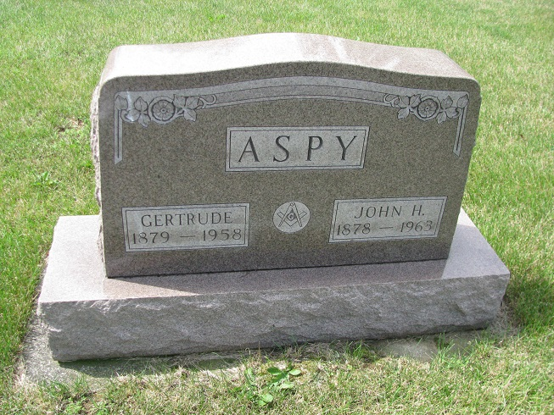
Photo by PLS

WIFE OF JOHN ASPY TAKEN BY DEATH THURSDAY
Funeral at Geneva on Sunday for 78-Year-Old Woman

Mrs. Ella Gertrude Aspy, 78, Geneva, wife of John A. Aspy, died at 1:25 a.m. Thursday morning at the Jay County hospital. She had been in poor health for several years, suffering from diabetes, and her condition had been critical during the past few days.
Mrs. Aspy was born Dec. 17, 1879, at Piqua, Ohio, the daughter of John B. and Sarah Holmes Shimp. She came to the Geneva community with her parents while a child and the family settled on a farm a mile east of Geneva.
On September 23, 1905, she was married to John H. Aspy. The couple has spent their entire married life in Geneva and vicinity, Mr. Aspy serving as rural mail carrier out of the Geneva post office until his retirement several years ago. Mrs. Aspy was a member of the Limberlost Church of Christ.
Surviving are the husband, John H. Aspy, two brothers, Jesse Shimp of near Geneva, and Silas Shimp, in Michigan, and one sister, Mrs. Sadie Weaver, residing east of Geneva. Two nieces, Mrs. Leland (Olive Shimp) Buckmaster of Akron, Ohio, and Mrs. Fay Ramier of Fort Wayne, spent several years in the Aspy home while attending Geneva school and after their graduation until they married and moved away. Mr. and Mrs. Aspy were as close to them as their own parents could have been, and Mrs. Buckmaster has been here frequently during times when sickness threatened the aged couple.
The body was taken to the Hardy & Hardy Funeral Home where friends may call.
Funeral services will be held at the Funeral Home at 1:30 p.m. Sunday. Rev. Floyd M. Myers of the Portland Church of Christ will officiate. Burial will be at Riverside cemetery.

Berne Witness, Adams County, IN; September 26, 1958

Contributed by Karin King

