Selma G. (Foster) Baker
August 4, 1914 – September 22, 2007
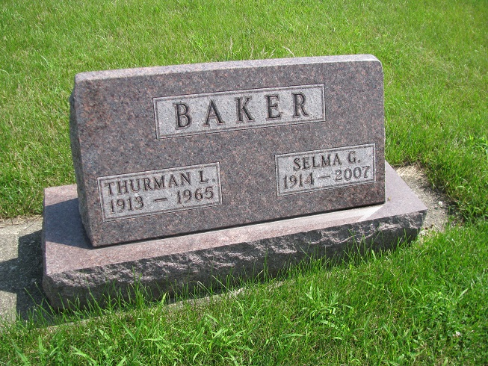
Photo by PLS

Selma Baker, 93, of Berne, died at 3:25 p.m. Saturday, September 22, 2007, in Chalet Village Health Care Center in Berne. Born in Geneva to William and Gail (Wall) Foster on August 4, 1914, Mrs. Baker married Thurman L. Baker on October 21, 1933 in New Corydon; he preceded her in death on October 19, 1965. A graduate of Summerville High School in Summerville, N.J., she worked at CTS in Berne for many years. She was a member of the Adams County Women's Democratic organization to which she was a precinct committee member and a delegate to the state. She also managed the Geneva License Branch for eight years and was a member of the High Street United Methodist Church. Surviving relatives include three daughters, Helen (David) Stucky of Geneva, Marilyn (Larry) Hanni of Indianapolis and Becky (Dewey) Balsley of Indianapolis; 12 grandchildren, 27 great-grandchildren and two great-great-grandchildren. Mrs. Baker was also preceded in death by a daughter, Clara Hamblen. A graveside service will be at 12:30 p.m. Saturday at Riverside Cemetery in Geneva with the Rev. James Bontrager officiating. There will be no visiting hours or funeral services.

Bluffton New Banner, Wells County, IN; Tuesday, September 25, 2007, p. 3, c. 1

