Clara Constance (Pyle) Bruhn
August 20, 1877 – August 9, 1943

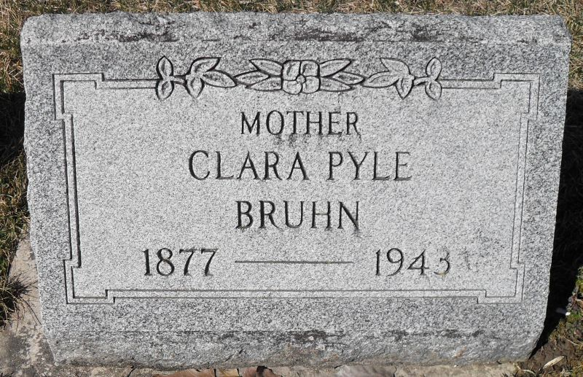
Stephen & Andrea Brangan

(Handwritten date: Monday, August 9, 1943)

MRS. WM. BRUHN DIES AT GENEVA
Funeral For Mother Mrs. Elmer Inniger On Thursday P.M.

Mrs. Clara Constance Bruhn, 65, wife of William Bruhn of Geneva, and mother of Mrs. Elmer Inniger of this place, died this morning at 8:05 o'clock at her home on East Line street in Geneva following a seven-month illness with cancer.
The deceased was a native of the Geneva vicinity, having been born two miles southeast of that town and would have been 66 on August 20. She was a daughter of Andrew Jackson and Mary Ann Siberry Pyle. She was married to Mr. Bruhn in Decatur, in November, 1913. Her entire married life was spent in Geneva.
Surviving are three daughters, Mrs. Mary Inniger of this place, Miss Eleanor of Muncie, and Miss Grace Bruhn of Fort Wayne; a granddaughter; a sister, Mrs. Nettie Aspy southeast of Geneva; two brothers, Fred and Harvey Pyle.
A daughter, Marie, died in 1929, and a sister died in infancy.
The body was taken to the Yager mortuary here and will be returned to the home in Geneva at 2 o'clock Tuesday afternoon, where friends may view it until time for the funeral, which will be on Thursday afternoon. A house service will take place at 1:45 and at 2 o'clock at the Geneva United Brethren church of which she was a lifetime member. Services will be conducted by Rev. R. S. Miller and Rev. C. W. Fawns will assist. Burial will be in Riverside cemetery.

Adams County (IN) Historical Museum
1943B Scrapbook, image 83
Transcribed by Karin King

