Charles Emerson Fields
1874 – July 1, 1956
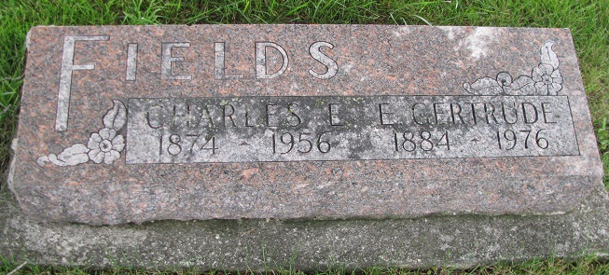
Photo by PLS

FIELDS
Geneva, July 1 –
Charles Emerson Fields, 82, a retired oil field worker, died at 9 am today in his home here after a two-day illness. He was born here and always lived here except for eight years in Oklahoma.
Surviving are the widow, Gertrude; a son, Harold Fields, Geneva; five grandchildren and 12 great-grandchildren.
Mr. Fields was a member of the Methodist Church here.
The body is at the Hardy & Hardy Funeral Home where friends may call. Services will be conducted at 2 pm Tuesday in the funeral home with the Rev. Roger Lautzenheiser of Elkhart, formerly of Geneva officiating, assisted by the Rev. Harold Schram, pastor of the local Methodist Church. Burial will be in Riverside Cemetery, east of here.

Journal-Gazette, Allen County, IN; July 2, 1956, p. 2

Contributed by Jim Cox

