Velma Ellen (Burley) Mosser
August 9, 1885 – June 19, 1964

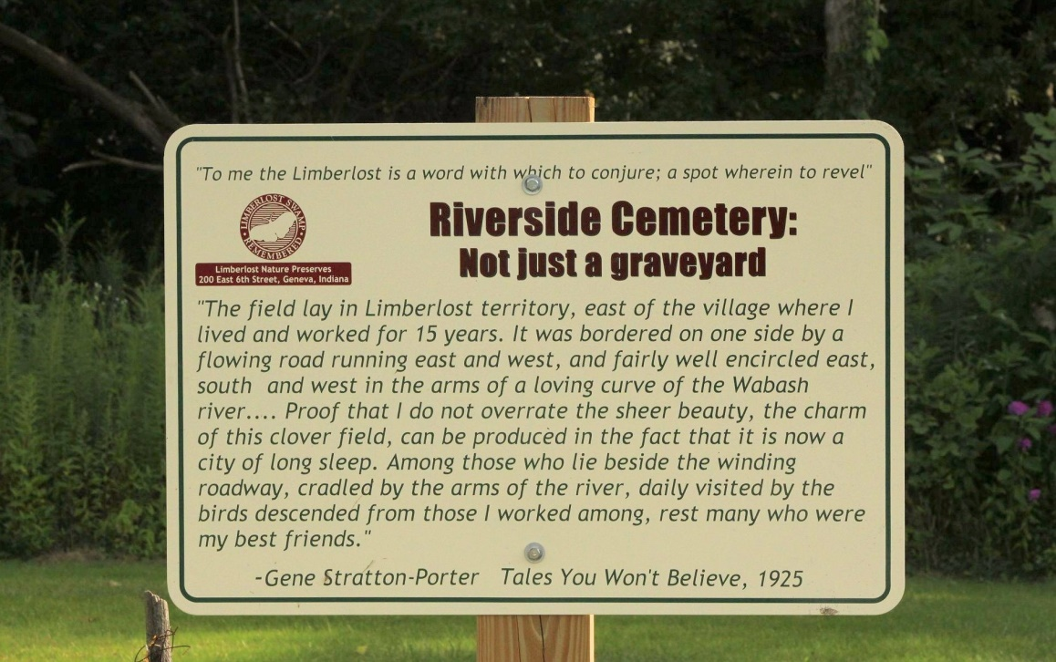
Photo by Tombstoner & Family
Mrs. Velma Mosser Is Taken By Death
Mrs. Velma Ellen Mosser, 78, died Thursday at the home of a son-in-law, Irvin Moore, Geneva. Four daughters, two sons, two brothers and one sister survive.
Services will be held at 2 p.m. Saturday at the Hardy & Hardy funeral home in Geneva. Burial will be in Riverside cemetery at Geneva. (Fri. June 19, 1964)
Berne (IN) Library Heritage Room
Adams County Obits 1962-1964
Transcribed by Janice Vasilovski

