Alice (Sharp) Orndorff
October 26, 1853 – October 3, 1938

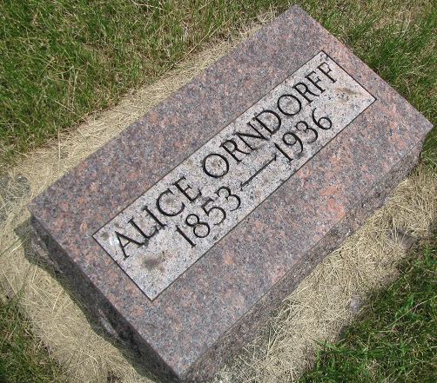
Photo by PLS

Indiana, Death Certificates, 1899-2011
Name: Alice Orndoff
Gender: Female
Race: White
Age: 84
Marital Status: Widowed
Birth Date: 26 Oct 1853; Birth Place: Ohio
Death Date: 3 Oct 1938; Death Place: Adams, Indiana, USA
Father: Wm Scharp [looks like Sharp]; Mother: Alice Showalter
Informant: Frank Orndoff, Geneva
Burial: 10/6/1938, Riverside Cemetery

