Albert Smith
1872 – July 23, 1943

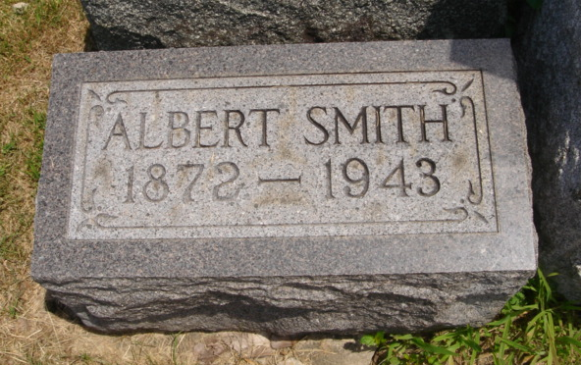
Photo by Cousin Becky

Thursday, July 29, 1943

Albert Smith Dies Friday

Albert Smith, well-known Wabash Township farmer, passed away at the Adams County Hospital in Decatur last Friday afternoon, where he had undergone major surgery. He had been a patient at the hospital for a week.
Mr. Smith was well-known in Geneva and community. He had never married and he lived with his brother, John, also unmarried. They had lived together practically all of their lives. For the past several years they had been making their home on their farm, known as the Old Creek Farm in Wabash-Jefferson Township line. Until several years ago, when traveling was restricted, he spent the winters in Florida because of his health.
Mr. Smith was a member of the Church of God at Portland.
The body is at the Wells & Hardy Funeral Home here where it will lie in state until the time of the funeral at 2 o’clock Sunday afternoon at the Geneva Church of the Nazarene, Rev. Baumgartner officiating at the funeral. Burial made in Riverside Cemetery.

Adams County (IN) Historical Museum
1943B Scrapbook, image 79
Transcribed by Jim Cox

