Kenneth Archbold Van Emon
July 3, 1928 – March 4, 2018

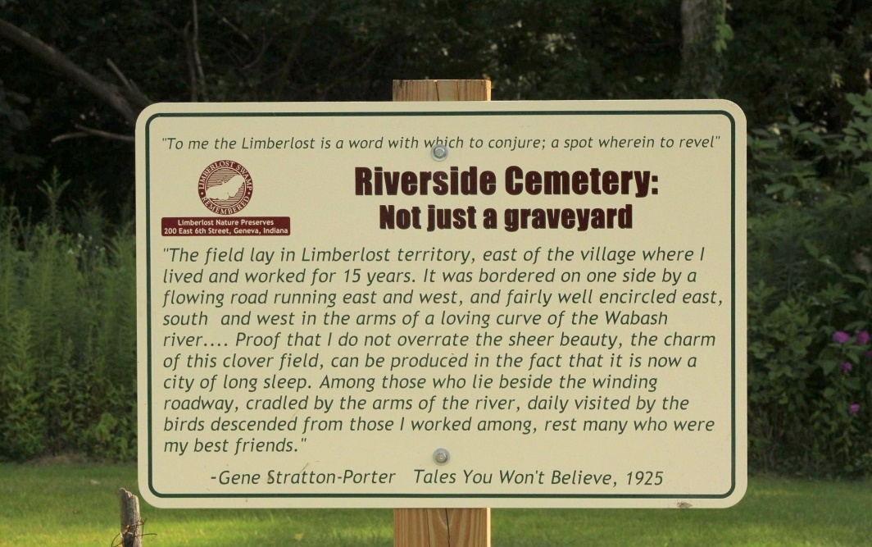
Photo by Tombstoner & Family

Kenneth Archbold Van Emon, 89, Berne, loving father and grandfather peacefully passed away on Sunday, March 4, 2018 at Swiss Village where he was a resident since 2010. He was born on July 3, 1928 in Adams County to Raymond and Lovina (Archbold) Van Emon. He was married on February 19, 1949 to Eula Dee Burk who preceded in death.
He graduated from Geneva High School in 1946. During high school he was a basketball player and he married his high school sweetheart, Eula Burk. He received his Bachelor of Science in Agriculture Education., Biology, and General Science from Purdue University in 1951. His first teaching position was at Geneva School where he taught vocational agriculture, biology, and general science. In 1963, he began his role as assistant superintendent of Berne-French Schools. He also served as assistant Superintendent for 18 years and later became Superintendent of South Adams Schools, a position he held for 2 years. Ken served in the education system for a total of 37 years retiring in 1988. In retirement, he enjoyed spending time with his wife, children, grandchildren, and great-grandchildren. He was a member of the Trinity United Methodist Church in Berne.
He is survived by a sister, Janice (Jim) Hubert and 6 sons, Stanley (Nancy) Van Emon of Berne; Michael (Janalyn) Van Emon of Carmel; Dennis (Elaine) Van Emon of Greenwood; Ned (Junko) Van Emon of McCordsville; Mark (Kim) Van Emon of Chesterfield, MO.; and Curt (Rachel) Van Emon of Lexington, Mass.; 4 daughters; Karen (Ronald) Crider of McCordsville; Joni (Stuart) Cagle; Janet (Guy) Taylor; Linda (Kevin) Burkett, all of Fishers, 22 grandchildren and 22 great-grandchildren.
Preceding in death are his wife, parents, sisters, Theora Elberson, in 2005, Rosalind "Jane" Van Emon Sordelet in 2008, and brother, Elwin Van Emon in 2014.
In liew of flowers, memorials contributions may be made to Adams County Community Foundation % of Kenneth and Eula Scholarship Fund to support graduating South Adams students pursuing undergraduate degrees in education. These monetary donations can be made on the Adams County Community Foundation website at www.AdamsCountyFoundation.org.
Funeral services are Wednesday, March 7, 2018 at 4 PM at the Swiss Village Auditorium with visitation from 2 to time of services. Officiating is Pastor Mike Wertenberger. Burial is in the Riverside Cemetery, Geneva.

Yager-Kirchhofer Funeral Home online obit (accessed 3/5/2018)

