Infant daughter Farlow
August 24, 1912 – August 26, 1912

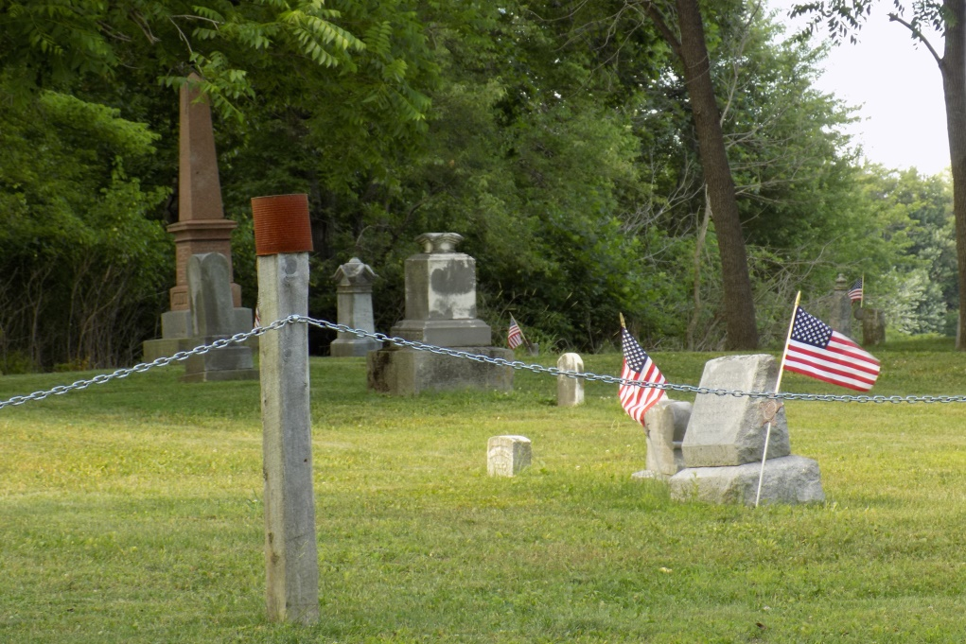

The infant daughter of Ben Farlow and wife which was born last Saturday night, died Monday night; it was buried at the Snow cemetery near Ceylon, Tuesday afternoon. Mr. Farlow and wife have the sympathy of their friends and neighbors, in this, their hour of bereavement. Mrs. Farlow is quite poorly yet; her mother, Mrs. Snow, of Geneva, is helping to nurse her.

Berne Witness, Adams County, IN; Friday, August 30, 1912

Contributed by Karin King

