Francis Marion Connor
1860 - 1940
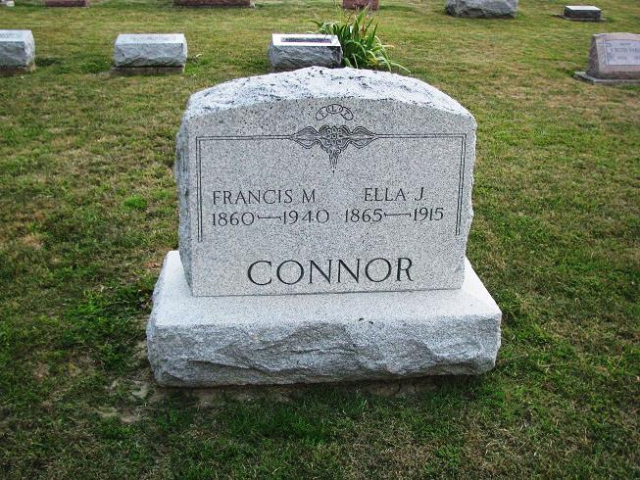
Photo by PLS
CONNOR
Geneva, May 18 –
Funeral services for Marion F. Connor, 80, retired plasterer and paperhanger who dropped dead in front of his home here, will be held Sunday at 2:30 pm at the Methodist Church here. Burial will be in the church cemetery.
Surviving are one daughter, one brother and one sister
Journal-Gazette, Fort Wayne, IN; May 19, 1940
Contributed by Jim Cox

