Coy R. Harbaugh
July 10, 1889 – January 20, 1971
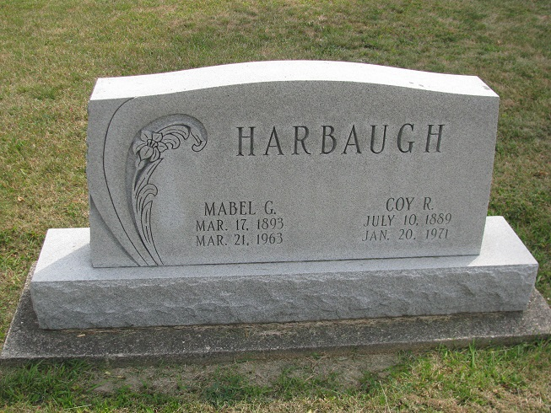
Photo by PLS

Coy Harbaugh
Warren – Coy R. Harbaugh, 81, a resident of the Methodist Memorial home, died at 6:40 a.m. Wednesday at Lutheran Hospital in Fort Wayne.
Mr. Harbaugh was a former resident of Geneva. He was a member of the Masonic Lodge.
The only survivor is a sister, Mrs. Ed Thurman, Geneva.
Funeral services will be conducted at 1:30 p.m. Friday at the Methodist Memorial Home Chapel with the Rev. Albert Clarke officiating. Burial will be in Westlawn Cemetery, Geneva. Friends may call anytime at the chapel.
Butler Funeral Home, Warren, is in charge of the arrangements.

Unknown newspaper clipping contributed by Linda Mabry

