Elizabeth (McCollum) Heeter
1881 – May 13, 1963

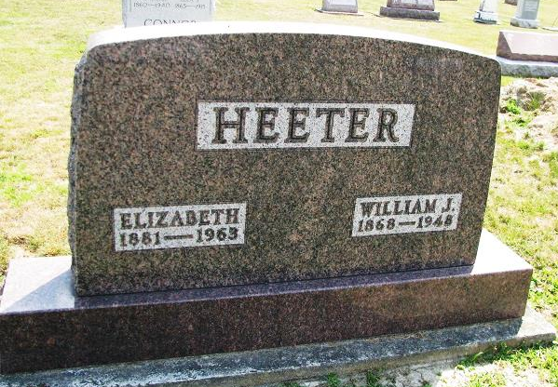
Photo by PLS

Elizabeth Heeter Dies Last Evening
Mrs. Elizabeth McCollum Heeter, 82, of Geneva, died Monday night at the Adams county memorial hospital, where she had been a patient for five months. Surviving are two sons, Ellis of Geneva, and John of Indianapolis, three grandchildren and one brother.
Funeral rites will be held at 2 p.m. Thursday at the Hardy & Hardy funeral home in Geneva, with burial win West Lawn cemetery. Friends may call at the funeral home after 7 p.m. today.
(Tuesday, May 14, 1963)
Berne (IN) Library Heritage Room
Adams County Obits 1962-1964, image 14
Transcribed by Janice Vasilovski

