Emma Irene (Cline) Sprunger
May 20, 1921 – May 14, 2018

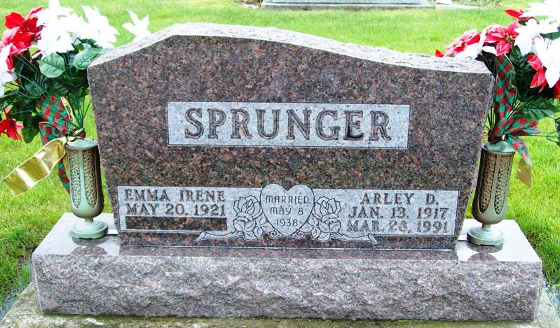
Photo by Jackie Sanders

Emma Irene Sprunger, 96, Berne passed away on May 14, 2018, at Swiss Village where she was a resident. She was born on May 20, 1921, in Jay County to Joseph Cline and Jessie Peel Cline. She married Arley Sprunger on May 8, 1938.
Irene was formerly employed at Fern's Dress Shop. She attended the Geneva Nazarene Church and First Missionary Church, Berne. She enjoyed gardening, flowering, cake decorating, crafts and crocheting.
Survivors include a son, Rev.Allen (Gloria) Sprunger of Saginaw, MI., daughters; Dianna Herman of rural Bluffton, Wanda Jesfield of Berne, daughter-in-law Willa K. Sprunger of Berne, 13 grandchildren, 25 great-grandchildren, and 7 great-great-grandchildren.
Preceding in death are her parents, husband, son, Leland Sprunger and 5 brothers and sisters.
Services are Friday, May 18, 2018, at 1:00 PM at Swiss Village with visitation from 10 AM to time of services. Officiating is Pastor Wilbur Taylor. Burial is in the Westlawn Cemetery, Geneva.
Preferred memorials to Gideon's International.
Yager-Kirchhofer Funeral Home online obit (accessed 5/15/2018)

