Ralph Otho Teeter
July 8, 1902 – April 8, 1963

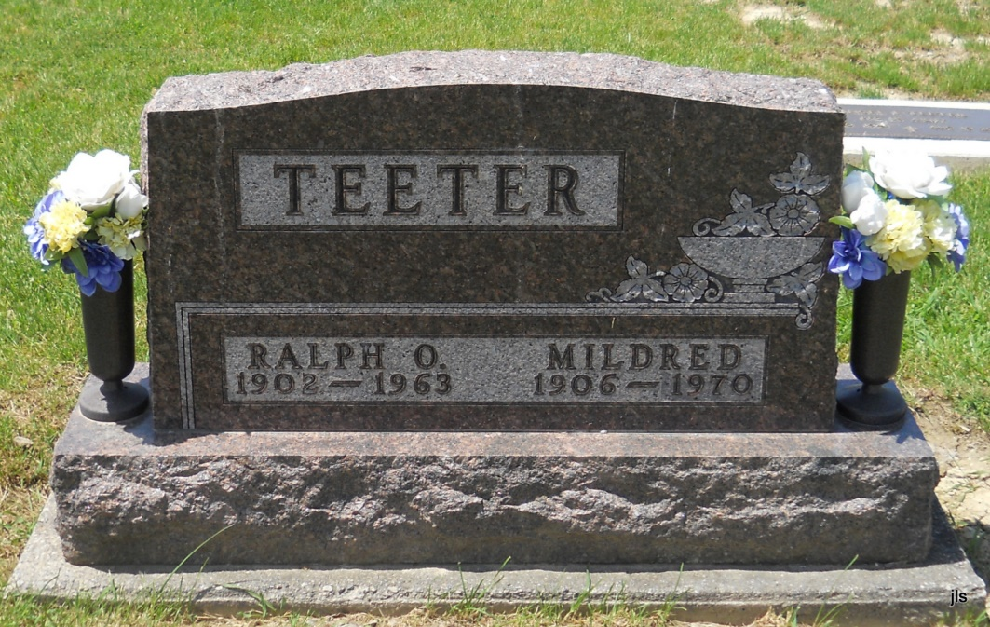
Photo by Jackie Sanders

Resident of Geneva Is Suicide Victim

A despondent Geneva man was found in his home this morning, more than 12 hours after he had committed suicide by hanging himself.
Ralph O. Teeter, 61, a resident of Line street in Geneva, was discovered by a friend at 10:45 a.m. today in the living room of his home, where he had hanged himself with a new rope which he had recently purchased.
Coroner Elmer Winteregg, Jr., established the approximate time of death at 8 o’clock Monday evening. Winteregg , state trooper Alan Coppes, sheriff Roger Singleton and deputy sheriff Harold August all agreed there was no evidence to suspect foul play.
Death was given by the coroner as “strangulation by hanging”.
Found By Friend
The body of the Geneva man was found by Elmer Mann, a friend, who had come to the home for a visit this morning. A former employee of Meshberger Bros. Stone Corp., Teeter had been living alone.
Teeter was reported to be despondent and was not himself in recent weeks. He had been arrested on a charge of public intoxication recently.
The body was brought to the Winteregg-Linn funeral home in Decatur, where funeral arrangements will be completed.
Teeter is survived by his wife, who lives in Geneva, and nine children. One son, Stanley, is a mortician in Portland. (Tues. April 9, 1963)
*****
Teeter Funeral Services Friday
Funeral services for Ralph O. Teeter, 61-year-old Geneva man who committed suicide Monday evening, will be held at the Baird funeral home in Portland at 10:30 a.m. Friday.
Friends may call at the funeral home after 12 noon Thursday until time of the services. Surviving Mr. Teeter are his wife Mildred, of Geneva; five sons, Stanley, mortician at the Baird funeral home; Kenneth of Delight, Ark., Binzel, Geneva; and Richard, at home; three daughters, Mrs. Robert (Mary) Teeple, Bryant; Linda and Vera Teeter, at home; and 15 grandchildren. (Wed. April 10, 1963)

Heritage Room, Berne (IN) Library Adams County Obits 1962-1964, image 32
Transcribed by Janice Vasilovski

