Sharon Kay (Baker) Abbott
January 6, 1938 – March 4, 2018

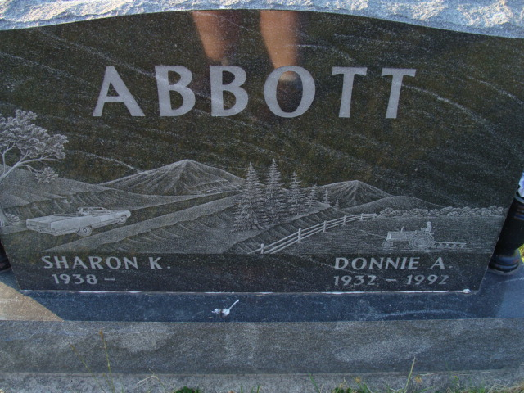
Photo by Alicia Kneuss

Sharon Kay Abbott, 80, of Decatur, IN passed away Sunday, March 4, 2018 at Sycamore Village in Ft. Wayne. Sharon was born in Decatur, IN on January 6, 1938 to the late Philip D. and Kathryn V. (Smitley) Baker Sr. On October 19, 1957, she married Donnie A. Abbott; he preceded her in death on December 23, 1992.
Sharon was a member of St. Luke Church, where she was involved in Helping Hands. She was a homemaker and also worked for CTS, H & R Block and Scott’s. Sharon was a member of the Good Sam Club and Decatur Coin Club. She was a 1956 Decatur High School graduate.
Survivors include her two sons, Scott A. (Kimela) Abbott of Huntertown and Patrick A. (Jackie) Abbott of Decatur; a daughter, Kathi A. (Daniel) Lyvers of Huntertown; 5 grandchildren, Erin, Sean, Elizabeth, Katherine and Cassandra and 5 great grandchildren, Mia, Samuel, Ella, Derek and Lyanna. Sharon was preceded in death by 2 brothers and a sister.
Visitation will be from 4:00-8:00 p.m. Friday, March 9, 2018 at Haggard-Sefton-Hirschy & Zelt Funeral Home, Decatur.
Funeral Services will be held at 10:00 a.m. Saturday, March 10th also at the funeral home with calling 1 hour prior to services from 9:00-10:00 a.m. Pastor Mike Wertenberger will be officiating and burial will be in Decatur Cemetery.
Memorials are to St. Luke Church.

Haggard – Sefton & Hirschy Funeral Home online obit (accessed 3/5/2018)

