Nina E. (Failing) Adams

July 7, 1879 – January 21, 1963

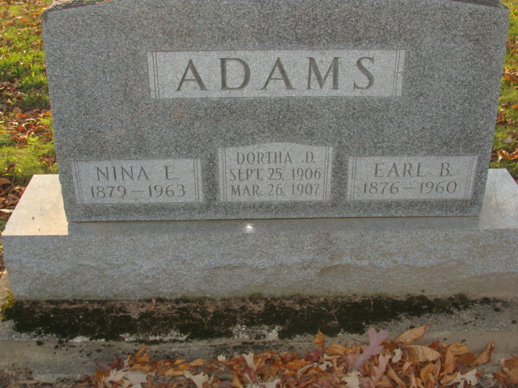

Photo by Alicia Kneuss

Mrs. Nina E. Adams Dies This Morning

Mrs. Nina E. Failing Adams, 83, of 306 Mercer Avenue, widow of Judge Earl B. Adams, a prominent Decatur attorney, died at 7:30 o’clock this morning at the Adams county memorial hospital. Her death followed an illness of several months of complications.

            Mrs. Adams, who had been prominent in church civic and social activities for many years, had lived in Decatur for 57 years.

            She was born in Flint, Mich., July 7, 1879, a daughter of Mr. and Mrs. James Failing, and was married to Earl B. Adams Sept 14, 1905?.  Her husband, a graduate of Decatur high school and the University of Michigan law school, was a practicing attorney in Decatur for many years and also served for several months as judge of the Adams circuit court.

            Mrs. Adams was a member of the First Presbyterian church, the Order of Eastern Star and the Shakespeare club.

            There are no near surviving relatives.  One daughter, Dortha, and one sister preceded her in death.

            Funeral services will be conducted at 2 p.m. Wednesday at the Winteregg-Linn funeral home, the Rev. Elbert A. Smith officiating.  Burial will be in the Decatur cemetery.  Friends may call at the funeral home after 7 p.m. today until time of the services.  (Mon. Jan. 21, 1963)

Berne (IN) Library Heritage Room

Adams County Obits 1962-1964

Transcribed by Janice Vasilovski