Quincy E. Ball
January 3, 1910 – August 6, 1992

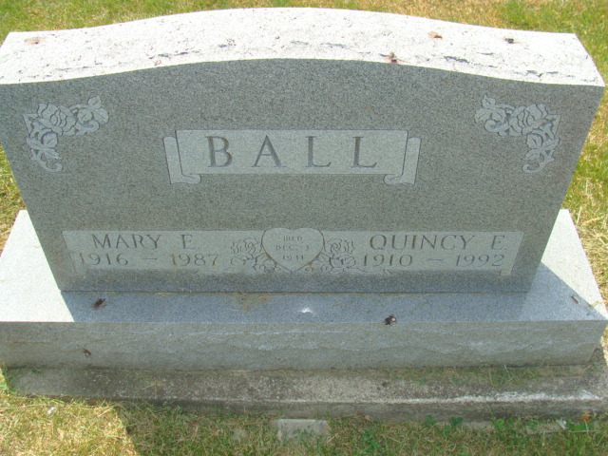
Photo by Alicia Kneuss

Quincy E. Ball, 82, died Thursday at Lakeside Manor Nursing Home, Decatur. A native of Morgan County, Ky., he retired from Decatur Salvage. His wife, Mary E. Keaton, died in 1987.
Surviving are his sons, William W. of Bluffton, James L. of West Liberty, Ky., and Elton R. of Butler; daughters, Geneva Prater of Bluffton, and Dorothy Costello, Anna B. Springer, Flora D. Wright, Dana G. Dyer, and Frieda L. Springer, all of Decatur; sisters, Dorothy Cox of Kentucky and Edna Keeton of Moorehead, Ky.; stepsisters, Florance Gilliam, Debbie Skaggs and Virginia Ball, all of Elkfork, Ky.; 40 grandchildren and 53 great-grandchildren.
Calling will be 10 a.m. Monday at Zwick-Sefton & Jahn Funeral Home, Decatur. Calling will be 7 to 9 p.m. today and noon to 9 p.m. tomorrow at the funeral home. Burial will be in Decatur Cemetery.

News-Sentinel, Allen County, Indiana
Saturday, August 8, 1992

