Chalmer Howard Barkley
November 7, 1915 – February 6, 2001

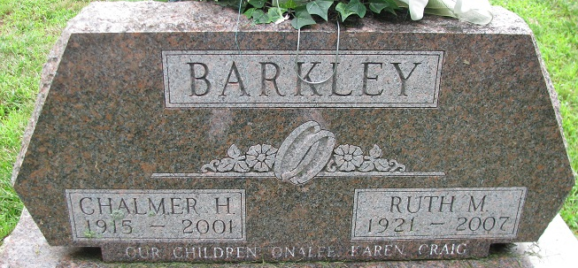
Photo by Alicia Kneuss

Chalmer H. Barkley, 85, of Decatur, a former member of the Decatur Planning Commission and City Zoning Board, died Tuesday, Feb. 6, 2001, at Woodcrest Nursing Home. The Allen County native was retired as a self-employed construction contractor. He was a former member of the County Tax Board and Adams County Law Enforcement Board. He was a member of St. Mark's United Methodist Church, where he served on several boards/offices, Masonic Temple 571 F&AM where he served as past master, and Fort Wayne Scottish Rite and Mizpah Temple. He was a World War II Navy Seabees veteran.
Surviving are his wife of 60 years, Ruth; a son, Craig H. of Decatur; daughters Onalee F. Elzey of Gahanna, Ohio, and Karen A. Hain of Zionsville; sisters Lucile F. Lehman and Barbara J. Huston, both of Fort Wayne, and Virginia E. Perry of Monroeville; 10 grandchildren; and eight great-grandchildren. He was preceded in death by two brothers and a sister.
Services are 11 a.m. Friday at Zwick & Jahn Funeral Home, Decatur, with calling from 3 to 5 and 7 to 9 p.m. Thursday with an 8:45 p.m. Masonic Service. Burial with military graveside services will be at Decatur Cemetery. Memorials are to Shriners Hospital for Crippled Children or the church.

News-Sentinel, Allen County, IN
February 7, 2001

