Emma L. (Kruetzman) Beineke
December 5, 1893 – August 24, 1979

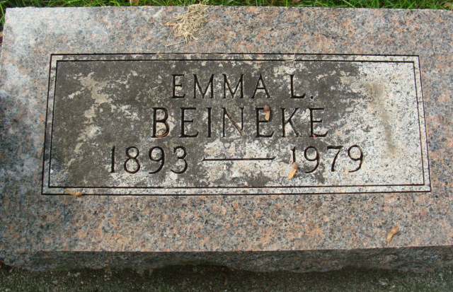
Photo by Alicia Kneuss

Mrs. Emma L. Bieneke, 85, 815 West Monroe Street, Decatur, Ind., widow of John E. Beineke, died at the Adams County Memorial Hospital, where she had been a patient since August 6. Death followed an extended illness.
Born in Magley on December 5, 1893, she was the daughter of Louis and Anna Scherry-Kruetzman and was married on October 28, 1914 to John E. Beineke, who died August 26, 1971.
Survivors include three daughters, Mrs. Hubert (Bernice) Fuelling, Monroe, Ind., Mrs. Edward J. (Ruth) Crowl, Fort Wayne, Ind., Mrs. C. B. (Mary) Wood, Fort Wayne; two sisters, Mrs. Earl (Orene) DeWeese, Decatur; Mrs. Paul (Marie) Neurge, Fort Wayne; one brother, Elmer Kruetzman, Detroit, Mich., eight grandchildren, and five great-grandchildren. Two brothers and three sisters preceded her in death.
Funeral services were held Sunday at the Zwick Funeral Home, Decatur. Burial was in the Decatur Cemetery.

Photo Star, Van Wert County, Ohio
Wednesday, August 29, 1979

