Fred D. Bell
July 19, 1884 – September 15, 1969

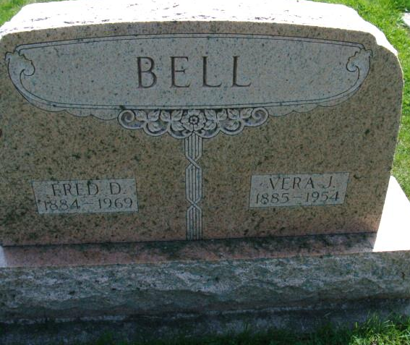
Photo by Alicia Kneuss

FRED D. BELL, 85, SERVICES HERE

Funeral services for Fred D. Bell, 85, Decatur native who died at 8 a.m. Monday at Victoria Hospital, Miami, Fla., after an extended illness, will be held at 2 p.m. Thursday in the Winteregg-Linn Funeral Home, the Rev. Melvin R. Seeger officiating.
Mr. Bell was born in Decatur on July 19, 1994 [sic], the son of Alexander R. and Dora Margaret Kunkel Bell. He was married to Vera J. Patterson on April 26, 1906, and they had two sons, Richard Bell, of Corona Del Mar, Cal. [sic - obit only names one son] Mrs. Bell died about ten years ago, and Mr. Bell married Mrs. Helen K. Patterson, who preceded him in death Dec. 13, 1965. He had retired some years ago from Wolf & Dessauer, in Fort Wayne. In 1966 he moved to the Miami area to be near his son and sister, Mrs. Pansy Helm, who survives. Five brothers and sisters preceded him in death: Charles K. Bell, Harry E. Bell of Elyria, O., Daisy M. Bell, Frank P. Bell and Irene "Pod" Bell.
He was a member of the First United Methodist Church of Decatur, and Decatur Lodge, F. & A.M. Masonic services will be held at 8 p.m. Wednesday.
The body is being returned to Decatur to the Winteregg-Linn Funeral Home, with visiting after 2 p.m. Wednesday.
Burial will be in the Decatur Cemetery.

Decatur Daily Democrat, Adams County, Indiana
Tuesday, September 16, 1969

