Daniel J. Bender
September 11, 1899 – June 10, 1920

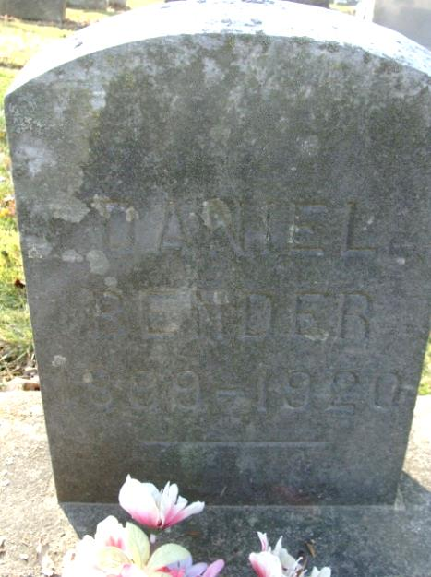
Photo by Alicia Kneuss

DAN BENDER DEAD

Daniel Bender, twenty-one years old, son of Mr. and Mrs. Fred Bender, of Pleasant Mills, died at the home of the parents, at one o'clock this afternoon, after an illness of several months from tuberculosis. The young man had been in California and after coming back to his home here was stricken and never regained his former good health. Two sisters, besides the parents, survive. No funeral arrangements had been made at 3:15 o'clock this afternoon.

Decatur Daily Democrat, Adams County, Indiana
Thursday, June 10, 1920
*****

Indiana, Death Certificates, 1899-2011
Name: Daniel J Bender
Gender: Male
Race: White
Age: 20
Marital Status: Single
Birth Date: 11 Sep 1899
Birth Place: St Mary TP Adams Co Ind
Death Date: 10 Jun 1920
Death Place: Pleasant Mills, Adams, Indiana, USA
Father: Frederick Bender
Mother: Jenny S. Yager
Informant: Mrs. Fred Bench, Pleasant Mills, Ind.
Burial: June 13, 1920; Decatur Cem.

