William Blackburn
July 19, 1836 – August 8, 1923

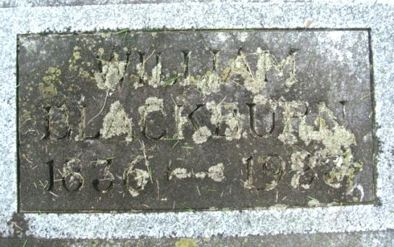
Photo by Alicia Kneuss

WILLIAM BLACKBURN ANSWERS FINAL SUMMONS TODAY
Pioneer Citizen of Decatur Passes Away at Home on South Sixth Street - DROVE STAGE COACH
Life Filled With Kindness and Service to Public and Friends
William Blackburn, 87, known to hundreds at "Uncle Billy", one of the pioneer of Decatur and Adams county who drove a stage coach long before other modes of travel were ever heard of, died at 5 o'clock this morning at his residence, 121 South Sixth Street following an illness of one month, during which time he showed remarkable endurance for a man of his age. His death was caused by paralysis of the throat, having suffered one stroke three years ago, and another two weeks ago. He was in poor health two weeks before the final stroke.
The history of Mr. Blackburn's life is filled with acts of kindness and service. Coming to Indiana from Ohio when a mere lad, he was first a farmer, then a stage coach driver, a business man, and assessor of Washington township for a period of 16 years, until his failing health made it necessary for him to resign three years ago.
William Blackburn, son of Thomas and Anna Blackburn, was born in Richland County, Ohio, July 19, 1836. He was one of fourteen children. A few years after his birth, he came to Adams County with his parents and settled on a farm in Root Township. On February 19, 1863 Mr. Blackburn was married to Miss Rachel Dutcher, daughter of Samuel and Catherine Dutcher, who also settled in Root Township after migrating from Ohio. Last February Mr. and Mrs. Blackburn celebrated their sixtieth wedding anniversary.
Four children were born to Mr. and Mrs. Blackburn, one of whom died while young. The other three are Page Blackburn of Decatur; Mrs. Carrie Gwinner of Dodge City, Kan., and Mrs. Katie Burell of Rochester, Indiana. There are six grandchildren and six great-grandchildren.
For the first year following their marriage Mr. and Mrs. Blackburn resided on a farm in Root Township. The following year they moved to Decatur and Mr. Blackburn became a driver of a stage coach between Decatur and Ft. Wayne, and for a while drove as far east as St. Mary's, Ohio. During the several years that he drove a stage coach, Mr. Blackburn never experienced a hold-up.
After the stage coach began to give way to more modern means of travel, Mr. Blackburn purchased a grocery store in Decatur forming a partnership with Harlowe Mann. This store was located at the corner of Seventh and Adams streets. Mr. Blackburn remained in the grocery business for several years before selling out and engaging in various other business enterprises.
Mr. Blackburn served as trustee of Washington Township for sixteen years. During that period as a public servant, he made hundreds of warm friends. He also served two years as trustee of Washington Township.
One of Mr. Blackburn's characteristics was that he was always fond of children, even until summoned by death. He always was kind to them even during sickness and trouble. Mr. Blackburn always paid his respects to the dead, very seldom missing a funeral held in the city.
For several years Mr. and Mrs. Blackburn have lived alone in their little house on Sixth Street, doing their own chores. Of Mr. Blackburn's thirteen brothers and sisters, James Blackburn, of Ft. Wayne, is the only living. He is past 69 years old.

Decatur Daily Democrat, Adams County, Indiana
August 8, 1923

