Robert L. Bumgerdner
May 9, 1918 – May 19, 1963

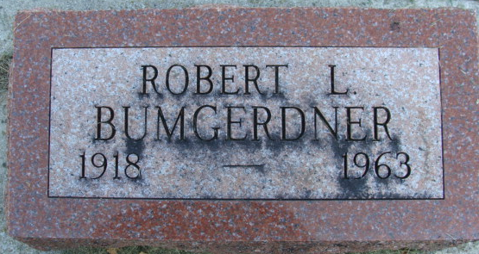
Photo by Alicia Kneuss

Robert Bumgerdner Dies Unexpectedly
Funeral services for Robert L. Bumgerdner, 45, son of Mr. and Mrs. Weldon E. Bumgerdner, of Decatur, will be held at 11 a.m. Tuesday at the Chalfant-Perry Funeral Home, Fort Wayne.
Bumgerdner, in apparently good health, died suddenly at his home Sunday morning. He had gone downstairs for a cup of coffee, and came upstairs to ask his wife to call the doctor at once, as he had a pain in his right arm. She went down to call, and when she returned, he had already died.
A native of Churubusco, Bumgerdner was born May 9, 1918. He was a graduate of Decatur High School. He had been a grain merchandiser for Central Soya Co. in Fort Wayne four years, and had been with the company 23 years. He belonged to the Simpson Methodist church and was a veteran of World War II.
Surviving are his wife, Maxine; a daughter, Susan; his parents and one sister, Mrs. Charles Stonestreet, Decatur.
Friends may call at the Chalfant-Perry funeral home after 2 p.m. today. Dr. Evan H. Bergwell will officiate at the services Tuesday and burial will be in the Decatur Cemetery.
Heritage Room, Berne Library, Adams County, Indiana
Unknown newspaper clipping
Dated Monday, May 20, 1963

