Carleen (Kiser) Clark
January 20, 1931 – March 17, 2018

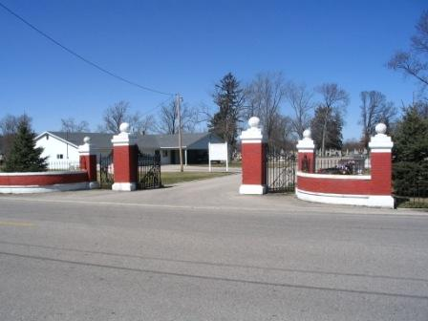
Photo by Barbara Baker Anderson

Carleen Clark, 87, of Fort Wayne, Indiana passed away at her residence on Saturday, March 17, 2018. She was born on January 20, 1931 to the late John Jacob and Ethel Mae (Mettler) Kiser. On February 9, 1952 she married Richard Clark.
She was a member of the American Legion Auxillary of Ft. Wayne. Carleen loved animals and was a supporter of Hope for Animals and Emilie Beard in Ft. Wayne. She was also a gifted musician.
Carleen is survived by her husband of 66 years, Richard Clark of Ft. Wayne, IN and two daughters, Cheryl (Tim) Ramsey of Decatur, IN and Sheri (Paul) Smith of Ft. Wayne, IN. She was preceded in death by 3 brothers and 4 sisters.
There will be visitation on Wednesday, March 21, 2018 from Noon until 2:00 p.m. at the Haggard-Sefton-Hirschy & Zelt Funeral Home. A Funeral Service will follow at 2:00 p.m. on Wednesday also at the Funeral Home. Burial will be held in the Decatur Cemetery.
Memorials may be given to the EB Feline Re-homing Service in Ft. Wayne.

Haggard-Sefton & Hirschy Funeral Home online obit (accessed 3/18/2018)

