George Foor
February 10, 1881 – August 13, 1963

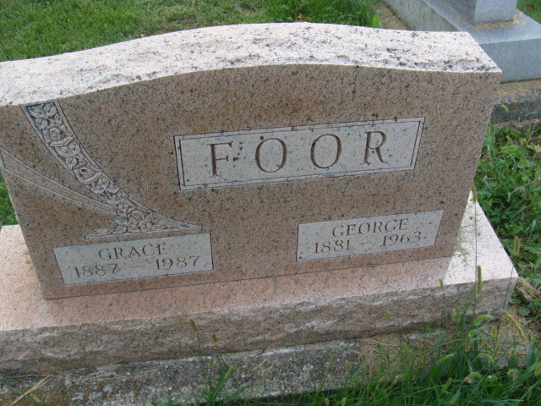
Photo by Alicia Kneuss
George Foor Dies At Home This Morning
George Foor, 82, retired Erie-Lackawanna railroad employee, died at 7:50 o’clock this morning at his home, 322 North 11th street, following an illness of nine weeks.
He was born at Waterloo, O., Feb. 10, 1881, a son of Joseph and Emma Foor, and was employed by the railroad for many years.
Surviving are his wife, Grace; two sons, Wilbur and Orval Foor, both of Decatur; four grandchildren, and five great-grandchildren.
Funeral services will be conducted at 2 p.m. Friday at the Winteregg-Linn funeral home, with the Rev. Lawrence Norris officiating. Burial will be in the Decatur cemetery. Friends may call at the funeral home after 2 p.m. Wednesday until time of the services. (Tues. Aug. 13, 1963)

Berne (IN) Library Heritage Room
Adams County Obits 1962-1964, image 25
Transcribed by Janice Vasilovski

