Walter F. Henning
June 5, 1910 – June 24, 1990

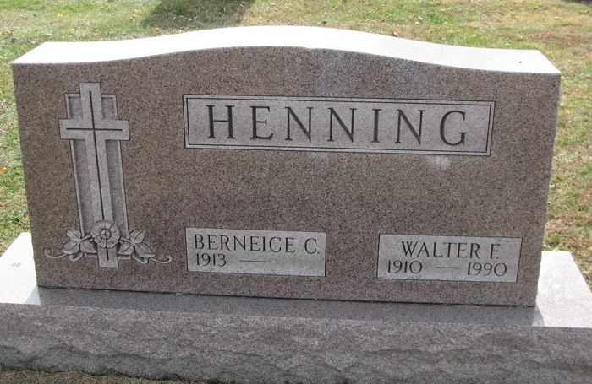
Photo by PLS

ANGOLA –

Walter F. Henning, 80, died Sunday at home. The Fort Wayne native retired in 1971 from International Harvester Co.
Surviving are his wife, Berneice; a daughter, Nancy Ross of Fort Wayne; a son; a brother, Albert of Fort Wayne; three grandchildren; and two great-grandchildren.
Services are 10 a.m. tomorrow in Peace Lutheran Church, Fremont, with burial in Maplewood Cemetery, Decatur. Calling is 2 to 4 and 7 to 9 p.m. today in Weicht Funeral Home, with an Elks memorial service at 6:45 p.m.

News & Sentinel, Allen County, Indiana
Tuesday, June 26, 1990

