George H. McManama
July 10, 1871 – April 26, 1962

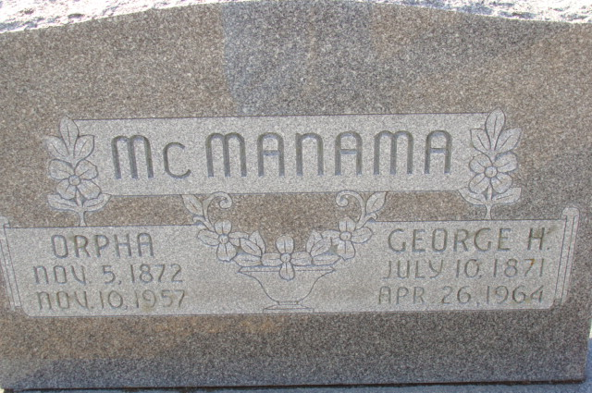
Photo by Alicia Kneuss

Handwritten date: Monday, April 27, 1964

George McManama Is Taken By Death

George H. McManama, 92, retired farmer, and former resident of the Decatur area, died at 1 o’clock Sunday afternoon at his home, 1121 Spy Run Ave., Fort Wayne, following a short illness. He was born in Cass County July 10, 1871, a son of William and Seralda Fisher-McManama, and lived in the Decatur area for many years before moving to Fort Wayne. His wife, Orpha, preceded him in death in 1957.
Surviving are two daughters, Mrs. Naomi Baumann of Berne, and Mrs. Mae Overholser of South Bend; one son, Howard McManama of Moline, Ill.; one brother Fred McManama of Fort Wayne; five grandchildren and several great-grandchildren. One son, two brothers and three sisters preceded him in death.
Funeral rites will be conducted at 2 p.m. Wednesday at the Gillig & Doan Funeral Home, with Rev. Elbert A. Smith Jr., of the Presbyterian Church, officiating. Burial will be in the Decatur Cemetery. Friends may call at the funeral home after 12 noon Tuesday until time of the services.

Berne Library Heritage Room, Adams County, Indiana
Obits 1962-1964

