Ina M. (Rabbitt) Meyer
March 17, 1892 – May 23, 1964

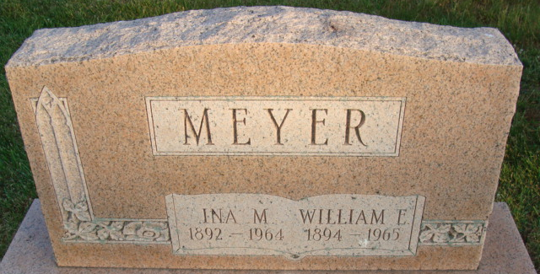
Photo of Alicia Kneuss

Mrs. Wm. E. Meyer Dies Late Saturday
Mrs. Ina M. Meyer, 72, wife of William E. Meyer, 616 Marshall Street, and a lifelong resident of this community, died at 11:15 p.m. Saturday at the Adams County Memorial Hospital. She had been ill for the past year and hospitalized for the past 17 days. Born in Adams County March 17, 1892, she was a daughter of Charles and Addie Drummond Rabbitt.
Mrs. Meyer was a member of the Church of the Nazarene.
Surviving in addition to her husband, owner of Meyer Body shop; are three sons, Richard and Robert Meyer, (twins), and Bernard Meyer, all of Decatur; one daughter, Mrs. Noble (Mary) Earhart of Bluffton; two grandchildren; three brothers, Bernard Rabbitt of Decatur, Edwin Rabbitt of Defiance, O., and Earl Rabbitt of Fort Wayne, and three sisters, Mrs. Henry Stauffer, Miss Erma Rabbitt, and Mrs. Jerome DeBolt, all of Decatur.
Funeral services will be conducted at 2 p.m. Tuesday at the Winteregg-Linn Funeral Home, with the Rev. Wilmer R. Watson officiating. Burial will be in the Decatur Cemetery. Friends may call at the funeral home until time of the services.

Berne Heritage Room, Adams County, Indiana
Monday, May 25, 1964

*****
Indiana, U.S., Death Certificates, 1899-2011
Name: Ina M Meyer
[Ina M Rabbitt]
Gender: Female
Race: White
Age: 75
Marital status: Married
Birth Date: 17 Mar 1892
Birth Place: Indiana
Death Date: 23 May 1964
Death Place: Decatur, Adams, Indiana, USA
Father: Charles Rabbitt
Mother: Addie Drummond
Informant: William E Meyer; husband; Decatur, Indiana
Burial: May 26, 1964; Decatur Cemetery; Decatur, Indiana

