Herman H. Myers
August 29, 1902 – March 28, 1936

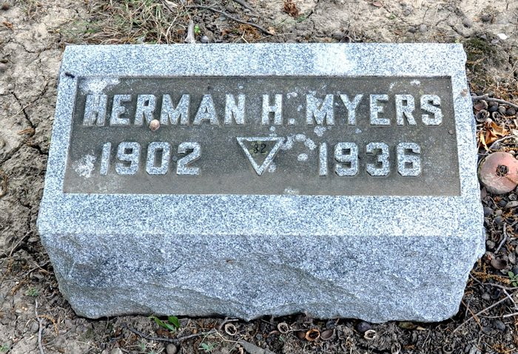
Photos by Alicia Kneuss

CRASH VICTIM GRADUATE OF I.U.
PROMINENT AS DEMOCRAT
Decatur, Ind., March 28 – Herman Meyers, Decatur City Attorney, who was killed in Indianapolis today, was a native of Decatur and had been City Attorney here since January 1, 1935. Prior to that, he was associated with his father in the clothing business here and in Bluffton.
He was graduated from Indiana University several years ago and later studied law in a Kentucky university. He was prominent in Democratic politics and a member of the M. E. Church here.
Surviving are the widow, one son, John; his parents, Mr. and Mrs. John F. Meyers, and a sister, Mrs. Robert Mills.
News-Sentinel, Allen County, Indiana
March 28, 1936

*****
Tragic Death is Severe Blow to Decatur and Vicinity
Hemorrhage Proves Fatal - Highly Popular
City Attorney Herman H. Myers, age 33, Decatur patriot who endeared himself to all with his gentlemanly qualities and manner, civic spirit and loyal companionship, died at 8:15 o'clock this morning in the Indianapolis City hospital, of a cerebral hemorrhage following injuries received in an auto accident about midnight Friday.
Mr. Myers and Myers went to Indianapolis Friday afternoon to visit with friends and attend the state basketball tournament.
In company with James Beatty, formerly of Decatur, secretary to Lieutenant-Governor Clifford Townsend and Paul Crozier, superintendent of the Citizens' Gas and Coke Co., Indianapolis, Mr. Myers attended the night session of the Bowling Congress tournament. The men were returning to their home when at the corner of Fall Creek Boulevard and North Meridian Street, their auto was struck by an auto driven by John West, negro, of Indianapolis.
Mr. Myers was the only one of the trio seriously injured. He was taken to the City hospital, where death resulted from the hemorrhage.
Word of the tragic accident was received here by friends last night. Mr. Myers' condition was considered serious and friends here were so advised. At about 8:30 o'clock, Dick Heller of Indianapolis called the Daily Democrat office and said Mr. Myers was dead.
Mr. Beatty and Mr. Crozier received bruises and cuts, but were not seriously injured and in a few hours were dismissed from the hospital.
News of his death came as a shock to the entire community. Public officials and citizens in general expressed their deep regret and sympathies over the untimely death of a leading citizen and friend.
Mr. Myers was a native of Decatur, only son of Mr. and Mrs. John T. Myers. He was born in this city, August 29, 1902.
In 1920 he was graduated from the Decatur high school and in the fall of that year entered Indiana University. Later he obtained an appointment to West Point Military Academy and remained there for one semester, returning to Indiana University and was graduated from that institution in 1925 with an A.B. degree.
From 1925 to 1930, Mr. Myers was engaged in the clothing business with his father, the late John T. Myers. In 1931, he entered Cumberland University, Lebanon, Tenn., where he obtained his LL.B degree and opened a law office in this city, being associated with Attorney C. J. Lutz.
Following the 1934 election, Mr. Myers was appointed city attorney by Mayor A. R. Holthouse. He assumed his city office January 1, 1935, and his record is one of the finest ever accomplished by an appointee in the post.
In 1926, Mr. Myers was married to Miss Mary Oman of Bluffton. They have one son, John, age three.
As a youth and during his short business and professional career, Mr. Myers was always public spirited and took an active part in city and community affairs.
He was a member of the varsity basketball team during his high school years and was called on frequently to take part in home talent plays. He had a fine and wholesome sense of humor, was loyal to his friends and enjoyed the companionship of friends.
Mr. Myers gained wide experience during the past year as city attorney through the many legal contacts made in behalf of the city with the PWA and other federal and state agencies. Three weeks ago he and Councilmen George Stults and Forest Elzey went to Washington to appear before the PWA relative to obtaining approval of city projects.
During the last two weeks Mr. Myers was an active member of the sales committee for the Centennial Good-Will bonds. He was much interested in the success of Decatur's celebration of its 100th birthday next August.
Besides being city attorney, Mr. Myers was a member of the Decatur board of public works and safety.
He was a member of the First Methodist Episcopal church, the Masonic lodge and B.P.O. Elks.
Mr. Myers is survived by his wife and son, his mother, who is visiting in Ashland, Kentucky, with her daughter, Mrs. Robert Mills.
The Zwick and son left for Indianapolis....o'clock this morning....body. Funeral arrangements have not been made.

Decatur Daily Democrat, Adams County, Indiana
1936

*****
Indiana, U.S., Death Certificates, 1899-2011
Name: Herman Myers
Gender: Male
Race: White
Age: 33
Marital status: Married
Birth Date: 29 Aug 1902
Birth Place: Indiana
Death Date: 28 Mar 1936
Death Place: Indp Co, Marion, Indiana, USA
Father: John S Meyers
Mother: Druscilla Hower
Spouse: Mary Uman
Informant: Mary V. Myers; Decatur, Indiana
Burial: March 30, 1936; Decatur, Indiana

