William Pendleton Rice
January 1, 1820 – September 10, 1899
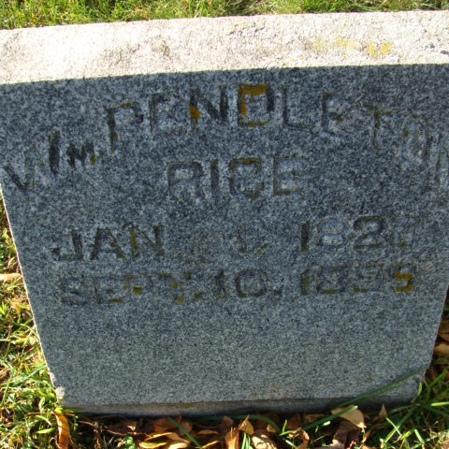
Photo by Alicia Kneuss

DECATUR. Ind. Sept- 11—W. Pendleton Rice, a pioneer of Indiana, died at his home In this city yesterday after a brief illness. Mr. Rice was born in Virginia, Jan, 1, 1820, and removed with his parents to Boone county, this State, in 1827. When a young man he came to Adams county and. after enduring the hardships of pioneer life, succeeded in clearing 250 acres, which is now one of the best improved farms in Indiana. He gave up farming several years ago and has been living a retired life in this city. He raised a family of nine children.
Indiana State Journal - September 13, 1899

Contributed by Karin King
*****
William Pendleton Rice b. Culpepper county, Virgina, January 1, 1820, died after an illness of many months, at his home in Decatur, Ind., September 10, 1899; aged seventy-nine years, eight months and nine days. He came with his father to Adams county in 1835, and settled in the woods upon a tract of land which had been entered by his father from the government. The early years of the life of the departed were spent amid the toils and the hardships incident to pioneer life. All these the subject of our sketch endured heroically and cheerfully. In March, 1843, he was joined in marriage to Miss Frances Rabbit, who had come with her parents from Virginia to Allen county, Ind., in 1837, and who mourns today the loss of her precious husband. For over fifty-six years this couple had walked together along the wedded pathway of life. The joys of life were the sweeter, the sorrows were the lighter and the responsibilities assumed were the more sacred for the loving fellowship of these beautifully blended lives. Of this union ten children were born, one of whom, Charles G., died at the age of nine years. The remaining children are Elizabeth H., Mary C., Joseph M., Sarah E., Alice A., William F., Nancy J., Frances S., and Benjamin J. The family circle has been widened to include forty-one grand-children and nineteen great-grand-children. The deceased by earnest toil and strict economy was enabled to enter forty acres of land northeast of the present town of Decatur. To these acres others were added from time to time, showing the business ability of the departed. In 1865 he purchased the Dent farm near Decatur, where he lived for a number of years. Upon leaving the farm he took up residence in Decatur of which he remained an honored and enterprising citizen until his death. At about fourteen years of age, the deceased was converted and at once united with the Methodist Episcopal church. During the years of his residence in the north part of the county his church membership was at East Liberty, on the Monroeville charge. Upon removing to the vicinity of Decatur his membership was transferred to the M. E. church of Decatur. In God's gracious providence he was permitted to reach a ripe old age. The many years of his life were well spent. In all the relations of life he was tender, true, self-sacrificing and Godfearing. His remains were laid to rest in Maplewood cemetery, and the funeral was one of the largest ever held in the city. Mr. Rice was an active member of the board of trustees of the Methodist church and the following memo...
No name or date on article
*****
William Pendleton Rice
On Sunday morning, just as the bells of various churches were calling our citizens to worship, the soul of one of the county's oldest pioneers, a man who has spent many years of his life in earnest endeavor to follow in the footsteps of Christ, was called to his eternal rest, there to be free from all earthly sufferings and trouble, there to worship in that house not built by hands, eternal in the heaven's. William Pendleton Rice died at his home, in the north part of the city, after an illness of many months, during which time he bore his suffers always uncomplainingly. He died of chronic dilation of the heart, complicated with gall stones and chronic inflammation and the growing together of the liver, stomach and contents of the right side. Several years ago while lifting at some work about his farm he over strained himself which caused the terrible complications and... Death has entered the ranks of the members of the official board of our church in calling from us our esteemed brother and official associate, William Pendleton Rice. We feel that in this event death has come very near to us. We greatly mourn his departure. Life to us has a changed aspect. We look to God for needed grace, and consecrate ourselves afresh to the great purpose of the Church of Jesus Christ. As members of the official board we record as follows the sincere feelings of our heart:
1. While in sorrow, yet we say, "God's will be done." God gave and God has taken away. Our ways are not His, but God's ways are best. God's wisdom and love assures us that this death must be for our good. 2. We are grateful to God for the privilege of having had as a member of the official board such a brother as was W. P. Rice. For over thirty years he has occupied an official position in this church, and at the time of his death was a trustee. In all of those years, until overtaken with ill health, he was faithful in ??? his duties. In the ??? the church he was ??? spiritual and self-sacrificing. He ??? his full share and in ??? making the church what is it today. 3. We extend to the bereaved widow and ??? most tender sympathy. (rest is unreadable)
Decatur Democrat (IN), Vol. XLIII, September 14, 1899

