Jeanette Rich

1915 – October 11, 1992

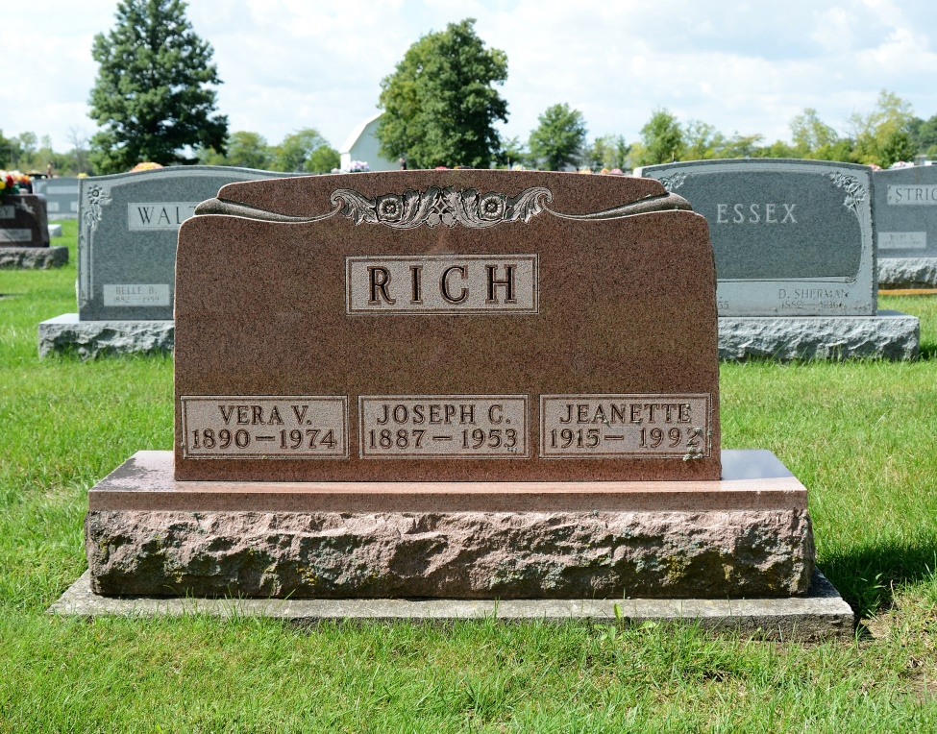

Photo by Deb Curry

Jeanette Rich, 77, of Carmel died Sunday in Carmel Care Center.
The Monroe native retired in 1976 as a music teacher for Fort Wayne Community Schools after 32 years. She was a member of Forest Park United Methodist Church.
Surviving is a friend, Joan Dillon of Fort Wayne.
Services are 1 p.m. tomorrow in D.O. McComb & Sons Lakeside Park Funeral Home, 1140 Lake Ave., where calling is 11 a.m. to 1 p.m. tomorrow. Burial will be in Maplewood Cemetery, Decatur.
Preferred memorials are gifts to the church.

News-Sentinel, The (Fort Wayne, IN); Tuesday, October 13, 1992
Contributed by Jane Edson

