Arthur W. Schamerloh
March 18, 1912 – November 2, 1972

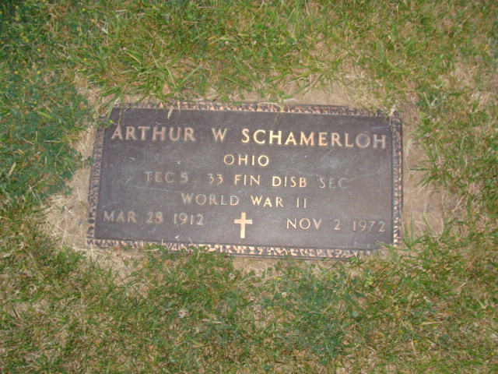
Photo by Alicia Kneuss

Services for Arthur W. Schamerloh, 60, of 1116 Union Street, who died at 8:05 am yesterday in the Veteran's Administration Hospital, will be at 2:30 pm Saturday at the Klaehn Funeral Home, the Rev. Ronald Janssen officiating.
Born in Decatur, he was a member of Emmanuel Lutheran Church and had been employed at the Forge Restaurant.
Surviving are his wife, Wilma; three children; a brother, Fred, in Decatur; and a sister, Mrs. Margaret Ashbaucher, Decatur.
Friends may call at the funeral home after 2 pm today. Burial will be in Decatur Cemetery.

Fort Wayne Journal-Gazette (IN); November 3, 1972, Page 2C

Contributed by Jim Cox

