Barbara Jean Smith
1931 – July 25, 1940
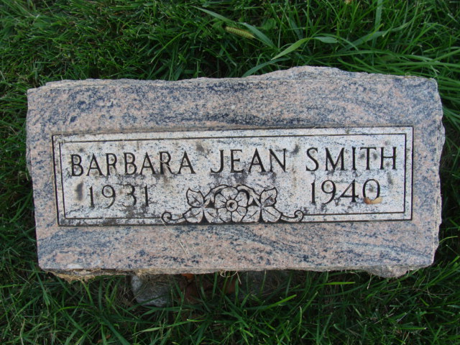
Photo by Alica Kneuss
SMITH
Barbara Jean Smith, eight-year-old daughter of Mr. and Mrs. Howard A. Smith of 1413 Grant Avenue, died of heart disease at 6:30 o’clock Thursday night at the Lutheran Hospital, where she had been a patient the last six days. She was a pupil in the third grade at McCulloch School, and attended the Fort Wayne Gospel Temple.
Survivors include the parents; one sister, JoAnn and two brothers, Richard Earl and Robert Wayne Smith at home; a grandmother, Mrs. Maud Acker of this city and three great-grandparents, Mrs. Clara Wysong of this city and Mr. and Mrs. Samuel Acker of Decatur.
The body was removed to C. M. Sloan & Sons Funeral Home, where it may be viewed after 7 o’clock tonight. Funeral services will be held Saturday at a time to be announced later. Burial will be at Decatur.
Journal-Gazette, Fort Wayne, IN; Friday, July 26, 1940
Contributed by Jim Cox

