Frank W. Smith
1867 – February 21, 1950
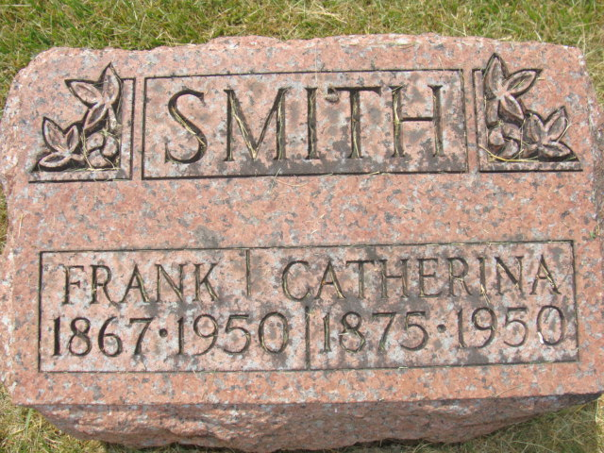
Photo by Alicia Kneuss

John Smith’s Brother Dies
Decatur, Ind.—Frank W. Smith, 82, brother of John Smith of Portland, died at 6 o’clock Tuesday morning at his home on Thirteenth St.
He was born in Servia, Ind., a son of Samuel and Harriet Egbert Smith and has resided in Decatur for several years.
Surviving are his wife, Katie; four sons, Charles of Decatur, Frank of Howe, Ernest of Celina, O.; two daughters, Mrs. Gladys Anderson and Mrs. Ruth Sells, both of Decatur; 32 grandchildren; 16 great-grandchildren; three brothers, Bill Smith of Decatur, Sam of Huntington and John of Portland. Seven children, two brothers and one sister are deceased.
Funeral services will be held at 1:30 p.m. Friday afternoon at the Black Funeral Home and at 2 o’clock at the Church of the Nazarene, Rev. Ralph A. Carter officiating.
Burial will be in the Decatur cemetery.
Portland Commercial Review, Jay County, IN; February 23, 1950

