Viola Mary (Roop) Smitley

June 8, 1889 – June 26, 1963

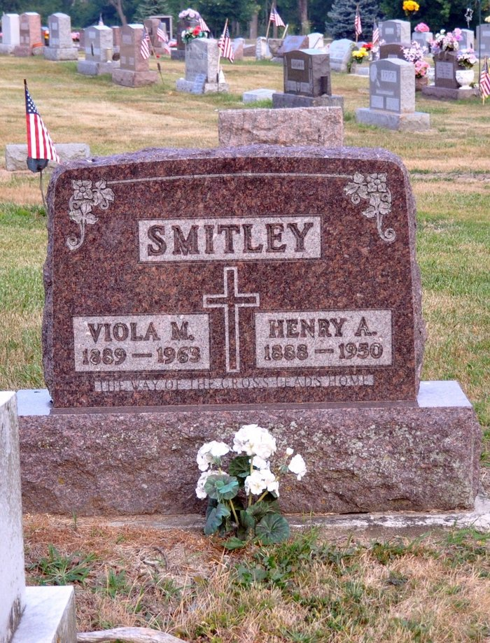

Photo by Deb Curry

Mrs. Viola Smitley, 73, resident of the Wagner Trailer Court on Pratt St., died about noon Wednesday following an illness of several years.

Mrs. Smitley was born June 8, 1890, in Willshire, a daughter of Samuel and Etta Roop. She was married Oct. 16, 1909, to Henry Smitley who died in 1950.

The deceased was a member of the Emmanuel Lutheran Church.

Survivors include three sons, Robert of Glenn St., Harold of Portland, Ind., Henry Jr. of Columbus; four brothers, Forrest Roop of Davis St., Rufus of Decatur, Harry of Toledo, Walter of Fort Wayne; two sisters, Mrs. Virgil Gamble of Middle Point, Mrs. Leah Thatcher of Burt St.; 10 grandchildren and 25 great-grandchildren. A daughter, a brother and two sisters are deceased.

Last rites will be at 3 p.m. Saturday at the Alspach Funeral Home, the Rev. F. H. Gerken to officiate. Burial will be in Maplewood Cemetery in Decatur. Friends may call at the funeral home after noon Friday.

**Times Bulletin, Van Wert County, Ohio; Thursday, June 27, 1963**

*****

Mrs. Viola Smitley Dies At Van Wert

Mrs. Viola M. Smitley, 73, died at noon Wednesday at the home in the Wagner trailer court at Van Wert, O., following an illness of several years.

She was born in Wilshire, O., June 8, 1890, a daughter of Samuel and Etta Roop, and was married to Henry Smitley Oct. 16, 1909. Her husband preceded her in death in 1950.

Mrs. Smitley was a member of the Emmanuel Lutheran church at Van Wert.

Surviving are three sons, Robert A. Smitley of Van Wert, Harold Smitley of Portland and Henry Smitley Jr., of Columbus, O.; 10 grandchildren; 25 great-grandchildren; four brothers, Forrest Roop of Van Wert, Rufus Roop of Decatur, Harry Roop of Toledo, O.;  
and Walter Roop of Fort Wayne, and two sisters, Mrs. Virgil Gamble of Middlepoint, O., and Mrs. Leah Thatcher of Van Wert. One daughter, one brother and two sisters are deceased.

Funeral rites will be held at 3 p.m. Saturday at the Alspach funeral home in Van Wert, the Rev. Francis H. Gerken officiating. Burial will be in the Decatur cemetery. Friends may call at the funeral home after 12 noon Friday. (Thursday, June 27, 1963)

**Berne (IN) Public Library Heritage Room**

**Adams County Obits 1962-1964, image 20**

**Transcribed by Janice Vasilovski**