Lenora V. Stauffer
September 29, 1926 – June 25, 1943

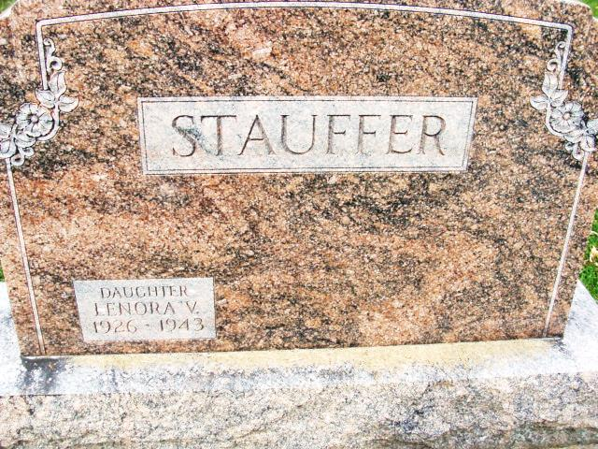
Photo by Alicia Kneuss

(Handwritten date: Saturday, June 26, 1943)
YOUNG DECATUR GIRL DIES FRIDAY NIGHT
Stauffer Funeral Monday Afternoon
Miss Lenora Stauffer, 16, Decatur junior-senior high school student and daughter of Mr. and Mrs. Gottlieb Stauffer of 228 North Sixth street, died last night at 8:30 o'clock at the home of her parents.
Death was caused by complications and followed an extended illness. She had been bedfast for the past 19 months.
The young girl was born in Decatur on September 29, 1926, the daughter of Gottlieb and Thelma Braun [sic]-Stauffer, and has resided here her entire life.
She was a member of the Zion Evangelical and Reformed church and of the girls' guild of the church. She was an only child. Surviving besides the parents, are the grandparents, Mr. and Mrs. Luther Brown, of Decatur and Mrs. Rebecca Stauffer of Monroe.
Funeral services will be held Monday afternoon at 1:30 o'clock at the home and 2 o'clock at the church with Rev. William Feller officiating. Burial will be in the Decatur cemetery.
The body will be returned to the residence from the Black funeral home Sunday morning and may be viewed after 1 o'clock Sunday afternoon.

Adams County (IN) Historical Society
1943b Scrapbook, Image 117
Transcribed by Karin King

