James C. Strickler
October 25, 1890 – August 30, 1964

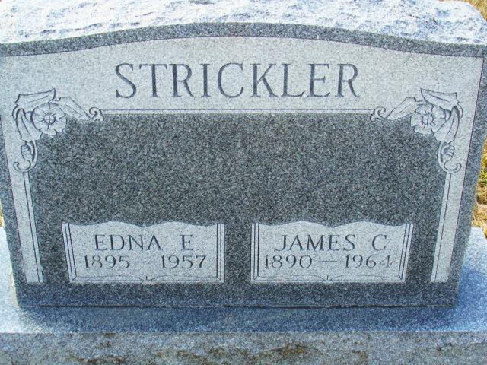
Photo by Alicia Kneuss

J. C. Strickler Dies After Long Illness

James C. Strickler, 73, lifelong resident of Adams county and Decatur, died at 11:20 o’clock Sunday morning at his home, 117 Porter Vista, following an illness of two years.
Mr. Strickler retired in 1960 from the Decatur Casting Co., where he had been employed for 41 years.
Born in Blue Creek township Oct. 25, 1890, he was a son of Grant and Emma Everett-Strickler. He was first married to Edna Durr, who died in 1957. He was married to Mrs. Mary Hazelwood in 1959.
Mr. Strickler was a member of the first Baptist church.
Surviving are his wife; three sons, Harold C. , Gerald G. and James J. Strickler, all of Decatur; eight grandchildren; two brothers, William Strickler of Redkey, and Russell Strickler of Fort Wayne, and eight sisters, Mrs. Cora Lautzenheiser of Decatur, Mrs. Effie Corbett of St. Paul, Minn., Mrs. Floyd L. (Lydia) Meyers of Salem, Mrs. Ed (Vernotia) Wolke of Fort Wayne, Mrs. Wilma Hoblet of Wilshire, O., Mrs. Henry B. (Jessie) Parrish, of Fort Wayne, Mrs. LeDoyle (Mabel) Feigley of Rockford, O., and Mrs. Norbert (Ruby) Huffman of Berne. One sister and one grandchild are deceased.
Funeral services will be conducted at 2 p.m. Wednesday at the First Baptist church, with the Rev. Robert L. Chidister officiating, assisted by the Rev. Richard Van Hoosen. Burial will be in the Decatur cemetery. The body was removed to the Winteregg-Linn funeral home, where friends may call from 7 to 10 p.m. today, 5-10 p.m. Tuesday, and 8 a.m. to 12 noon Wednesday, when the body will be taken to the church to lie in state until time of the services. (Mon. Aug. 31, 1964)

Berne (IN) Library Heritage Room
1962-1964 Adams County Obits
Transcribed by Janice Vasilovski

