Gertrude (Moyer) Sudduth
April 17, 1872 – May 14, 1940

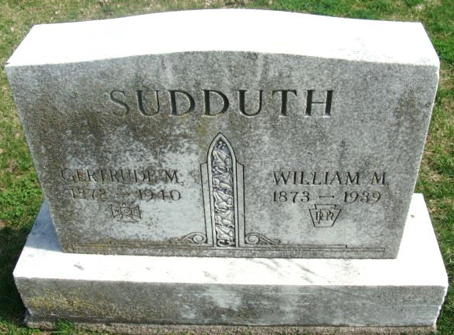
Photo by Alicia Kneuss

(Handwritten date: Tuesday, May 14, 1940)

DEATH CLAIMS MRS. SUDDUTH
Mrs. Gertrude Sudduth Dies This Morning At Hospital

Mrs. Gertrude M. Sudduth, 68, well-known Decatur resident, died this morning at 1:55 o'clock at the Adams county memorial hospital. Death was attributed to complications, following an illness of three years.
The deceased was born in Wells county April 17, 1872, the daughter of Mr. and Mrs. George Moyer. She came to this county when a young girl. She was a member of the First Baptist church.
Her husband, William Sudduth, preceded her in death in October of last year. The deceased was also a member of the Women's Relief Corps, an auxiliary of the GAR.
Surviving are a son, Orval, at home and one grandchild; the following brothers and sisters: Ben Moyer of Linn Grove, Mrs. Tom Fisher of Decatur, Henry of Hiawatha, Michigan; Samuel of Milwaukee; John of Meesick, Michigan. Ten brothers and sisters are deceased.
Funeral services will be held Friday afternoon at 2:30 o'clock (CDT) at the residence, 238 North Seventh street, with Rev. Paul Brandyberry, pastor of the Church of the Nazarene, officiating. Burial will be in the Decatur cemetery.
The body will be returned to the home from the S. E. Black funeral home Wednesday afternoon and may be viewed there after 4 p.m. until time for the services

Adams County Historical Museum
1940 Feb-Dec Scrapbook – image 130
Transcribed by Karin King

