Mary E. (Weddle) Swager
September 11, 1935 - October 26, 2016
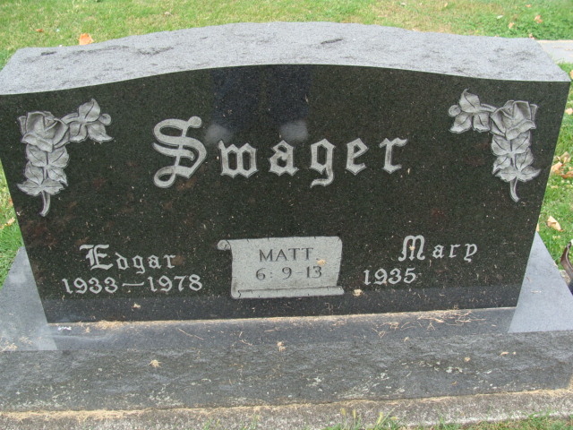
Photo by Alicia Kneuss

Mary E. Swager, 81 years old of Ohio City, Ohio, passed away on Wednesday, October 26, 2016 at Vancrest of Convoy.
She was born on Wednesday, September 11, 1935 in Mercer County, Ohio the daughter of the late Guy Weddle and the late Myrtle (Steen) Weddle. She married Edgar Glen Swager on August 21, 1955 at the Bethany Evangelical United Brethren Church in Decatur and he preceded her in death on August 26, 1978.
Mary was a member of the Willshire Union United Methodist Church where she was active in the United Methodist Women, served as a song leader & on the flower & communion committees. She was also a 4-H leader for many years in Van Wert County. Mary enjoyed knitting, gardening, traveling, and camping.
She was a 1953 graduate of Willshire High School and retired in 1990 with 37 years of service at the United States Post Office in Willshire where she served as the postmaster.
Surviving are her son, Loren (Joni) Swager of Continental, OH; son, Vaughn (Carol) Swager of Ohio City, OH; daughter, Charlene (Matt) Miller of Fort Wayne, IN; brother, Floyd (Arlene) Weddle of Fort Wayne, IN; and sister-in-law, Roberta Mattax of Fort Wayne, IN. She is also survived by five grandchildren, Ben (Tina) Swager; Gene (Elizabeth) Swager; Joey Swager; Darcci Swager; & Colby Swager.
Preceding Mary in death were a sister, Phyllis Weddle in infancy; two brothers, Ray & William Weddle; a brother-in-law, Max Mattax; and sister-in-law, Betty Weddle.
Funeral services will be held at 10:30 a.m. Tuesday, November 1, 2016 in the Willshire Union United Methodist Church with Pastor Richard "Bud" Larimore officiating. Interment will follow in the Decatur Cemetery.
Friends will be received from 2 to 5 and 6 to 8 p.m., Monday, October 31 in the Zwick & Jahn Funeral Home in Decatur and one hour prior to the service at the church on Tuesday.
Preferred memorials are to Willshire Union United Methodist Church; Special Olympics of Van Wert County; or State of the Heart Hospice in Coldwater.

Zwick & Jahn Funeral Home online obit (accessed 10/27/2015)

